**-**

Introduction

This project aims to tackle food waste and hunger by collecting leftover food from various sources and distributing it to those in need. It involves partnering with organizations, developing a platform for connecting donors and recipients, and ensuring food safety to minimize waste and address food insecurity**.**

# Problem Statement:

Food waste is a global issue, with significant amounts of edible food being discarded each year while millions suffer from hunger. In India, it's estimated that a substantial portion of food is wasted at various stages, from production to consumption.

# Project Goal:

To reduce food waste and alleviate hunger by creating a system for collecting leftover food from restaurants, events, and households and distributing it to those in need through established NGOs and community organizations.

# Target Beneficiaries:

The project will benefit individuals and families experiencing food insecurity, as well as the environment by minimizing food waste and resource depletion**.**

# Expected Impact:

* Reduced food waste and a significant reduction in food-related environmental impact.
* Improved food security for vulnerable populations.
* Increased awareness of food waste issues and solutions among the public.
* Enhanced community engagement and collaboration.

# Milestone – 1 Salesforce Account

**Activity 1: Creating Developer Account**

1. Creating a developer org in Salesforce.
2. Go to <https://developer.salesforce.com/signup>
3. On the signup form, enter the following details :

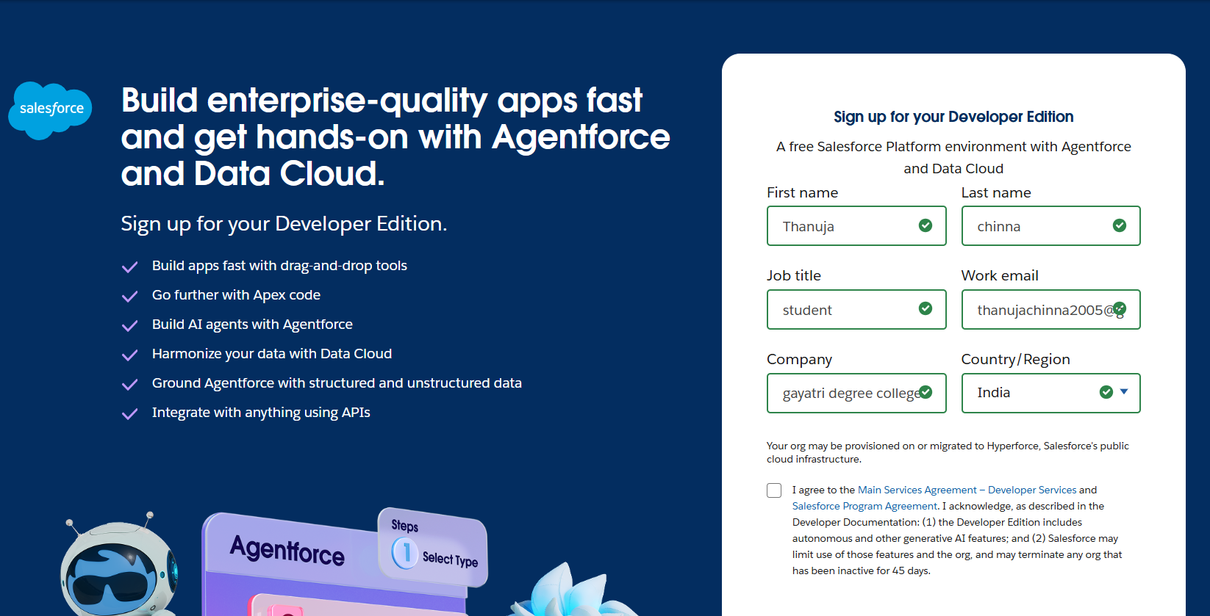

* + **First Name:** THANUJA
  + **Last Name:** Kavarenaidu
  + **Job title:** Developer
  + **Work Email: thanujachinna2005**[@gmail.com](mailto:singiriushasree13@gmail.com)
  + **Company:** GAYATRI DEGREE COLLEGE TIRUPATI
  + **Country/Region:** INDIA

1. Click on sign me up after filling these.

# Activity 2: Account Activation

1. Go to the inbox of the email that you used while signing up. Click on the verify account to activate your account. The email may take 5-10mins.

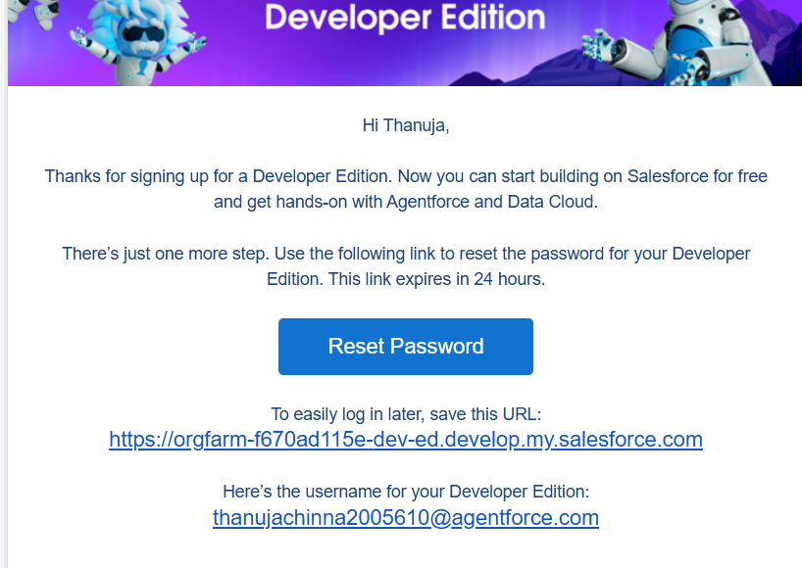

1. Give a password and answer a security question and click on Change Password.

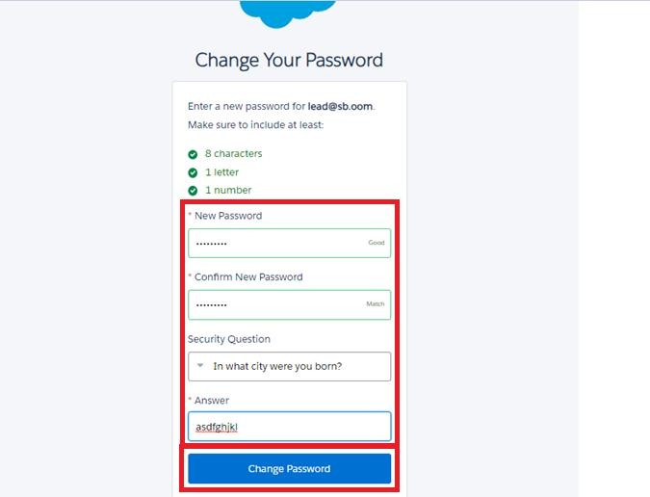

1. Then you will be redirected to your Salesforce setup page.

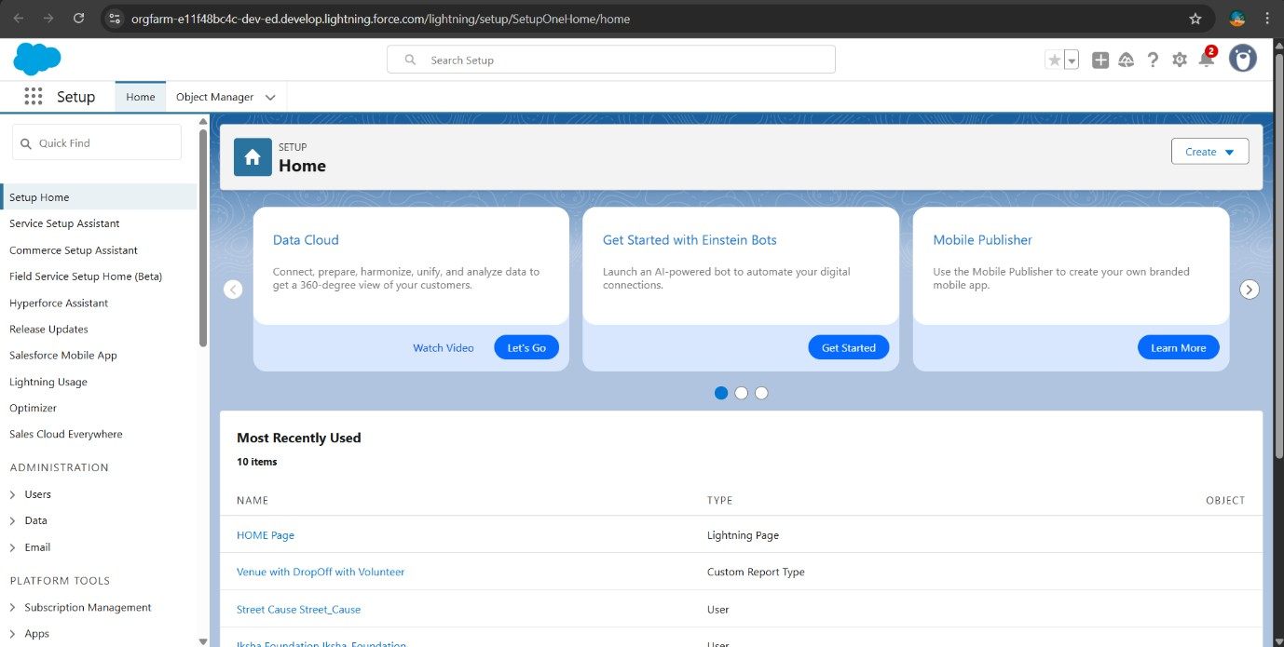

# Activity 1: Creating Venue object

From the setup page

1. Click on Object Manager

# Milestone – 2 Objects

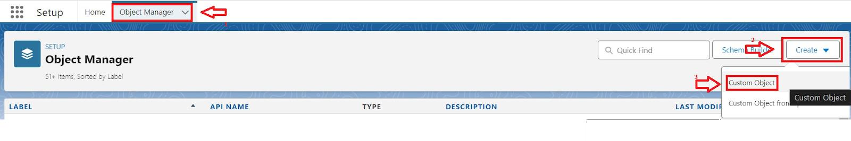

1. Click on Create >> Click on Custom Object.
2. Enter the label name as **Venue**.
3. Enter Plural label name as **Venues**.

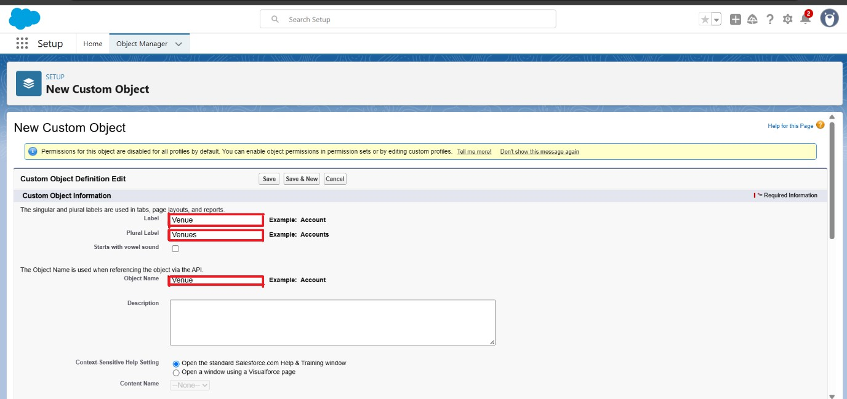

1. Enter Record Name as Venue name.
2. Select Datatype as Text.
3. Click on Allow Reports, Track field history, and Allow Activities.

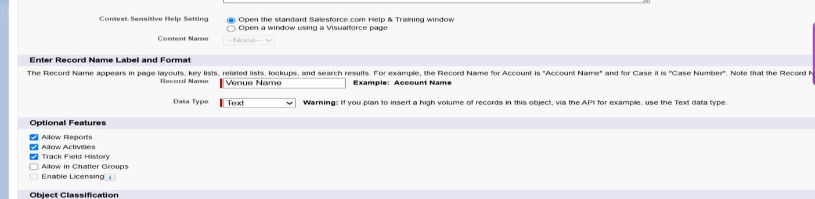

1. Click on Allow Search.

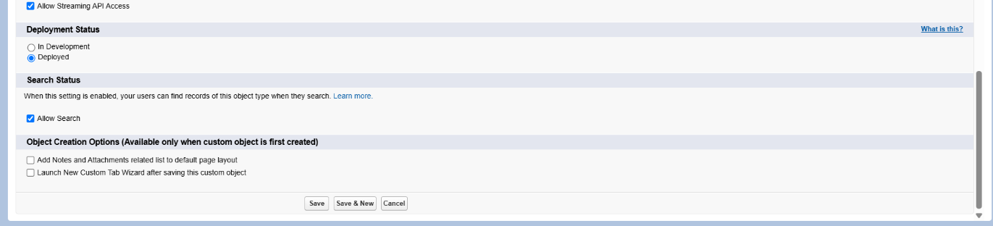

1. Click on Save and New.

# Activity 2: Create Drop-off Point Object

From the Setup page

1. Click on Object Manager
2. Click on Create >> Click on Custom Object.

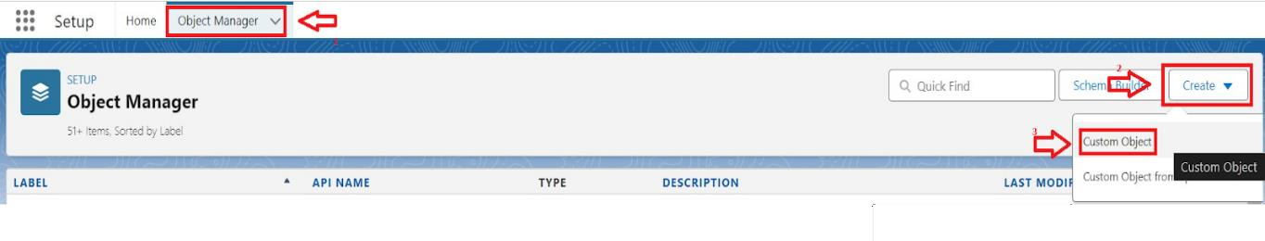

1. Enter the label name as **Drop-Off Point**.
2. Enter Plural label name as **Drop-Off Points**.

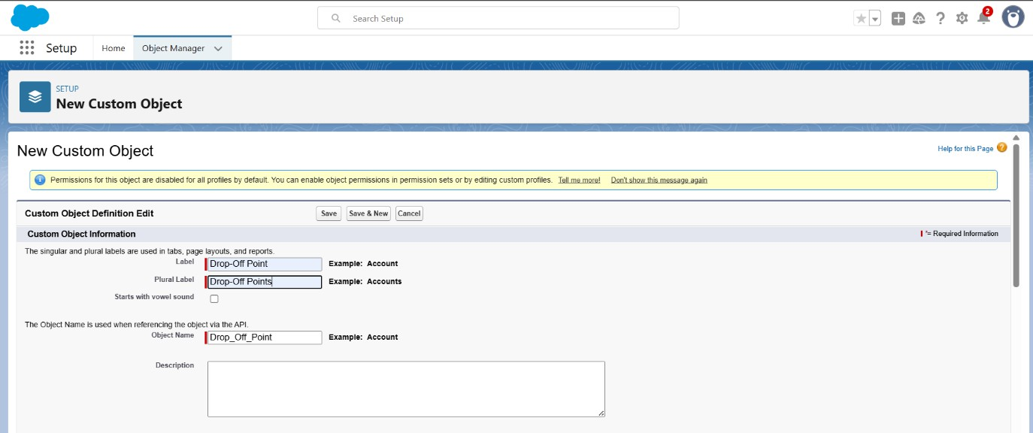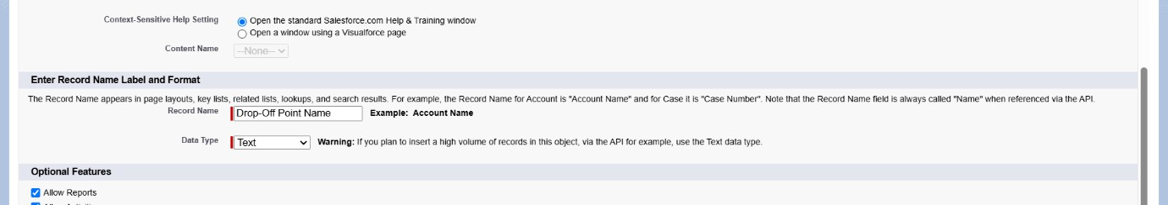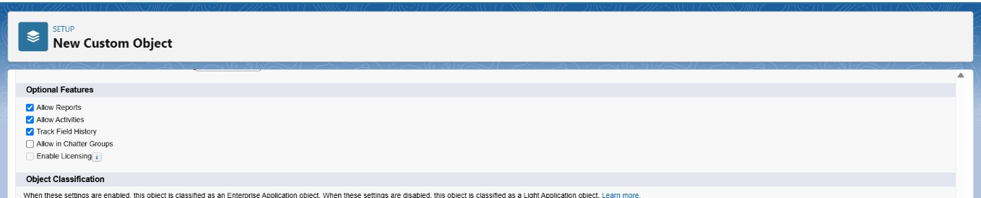

1. Enter Record Name as Drop-Off Point Name.
2. Select Datatype as Text.
3. Click on Allow Reports, Track field history, and Allow Activities.
4. Click on Allow Search.

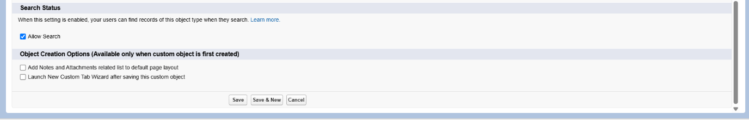

1. Click on Save and New.

# Activity 3: Create Task Object

From the Setup page

1. Click on Object Manager.
2. Click on Create >> Custom Object.



1. Enter the label name as **Task**.
2. Enter the Plural label as **Tasks**.

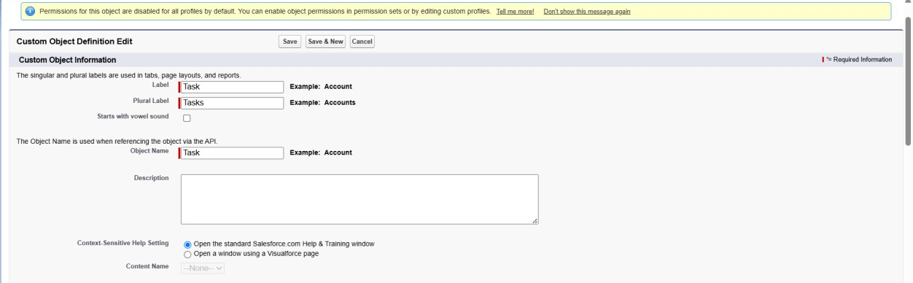

1. Enter Record Name as Task Name.
2. Select Datatype as Text.

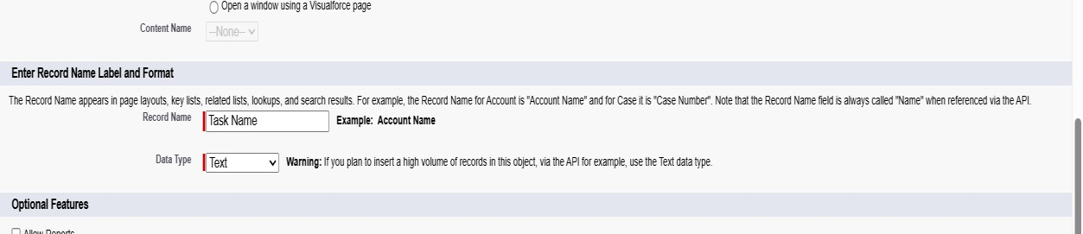

1. Click on Allow Reports, Track field history, and Allow Activities.
2. Click on Allow Search.

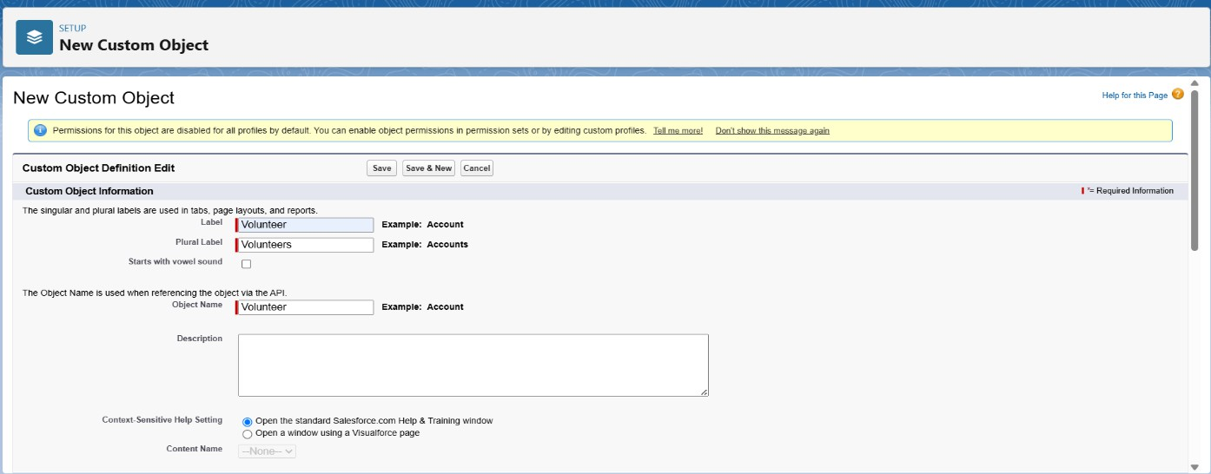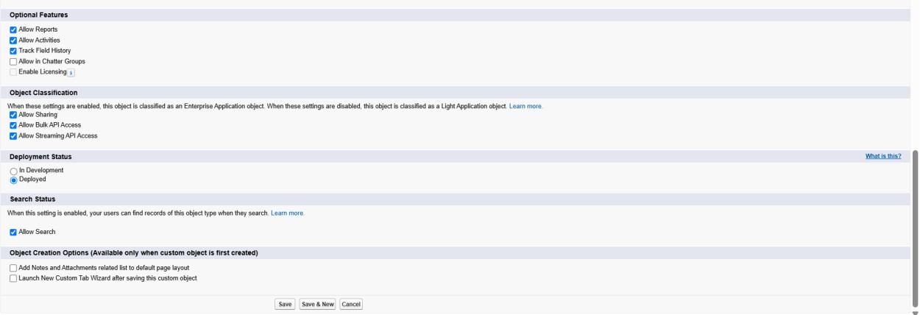

1. Click on Save and New.

# Activity 4: Create Volunteer Object

From the Setup page

1. Click on Object Manager.
2. Click on Create >> Custom Object.



1. Enter the label name as **Volunteer**.
2. Enter the Plural label as **Volunteers**.
3. Enter Record Name as Volunteer Name.
4. Select Datatype as Text.

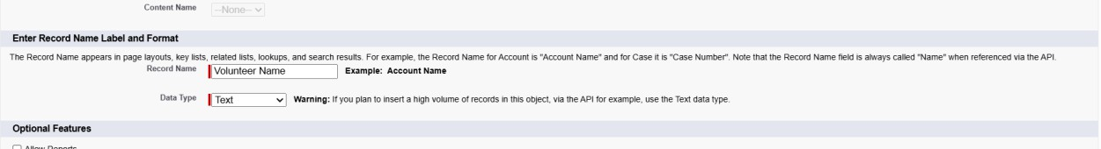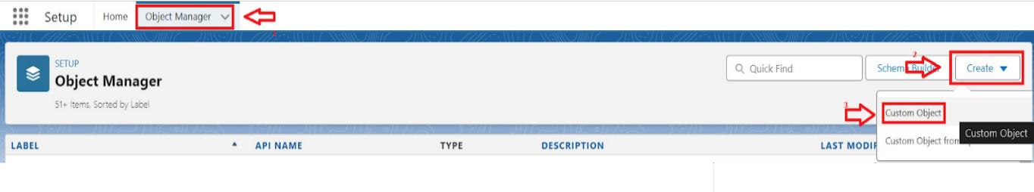

1. Click on Allow Reports, Track field history, and Allow Activities.
2. Click on Allow Search.
3. Click on Save and New.

# Activity 5: Create Execution Details Object

From the Setup page

1. Click on Object Manager.
2. Click on Create >> Custom Object.
3. Enter the label name as **Execution Detail**.
4. Enter Plural label name as **Execution Details**.

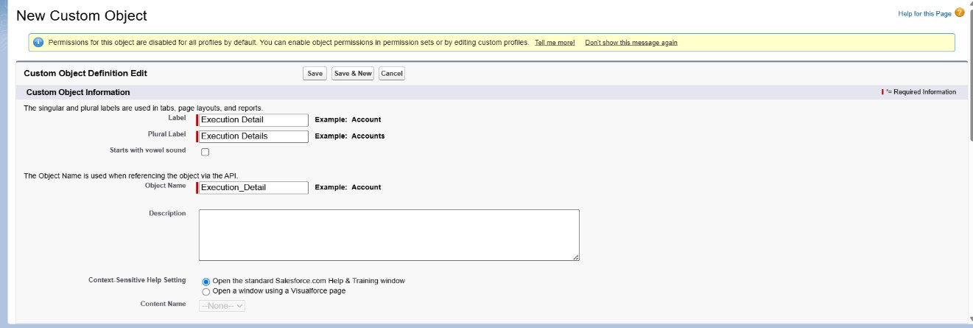

1. Enter Record Name as Execution Details Name.
2. Select Datatype as Text.

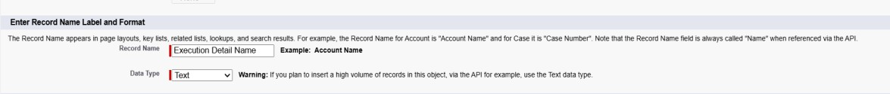

1. Click on Allow Reports, Track field history, Allow Activities.
2. Click on Allow Search.
3. Click on Save and New.

# Milestone – 3 Tabs

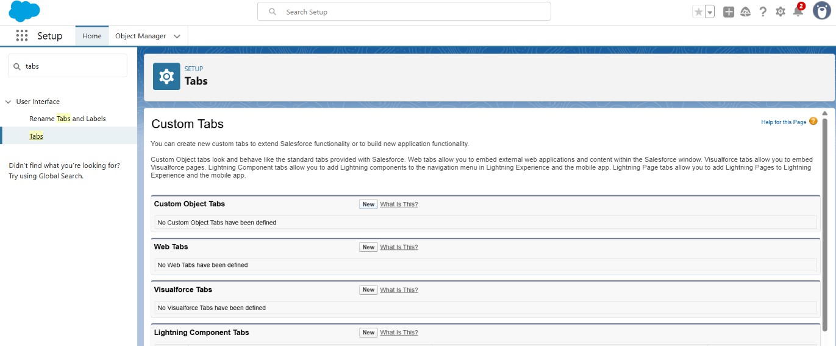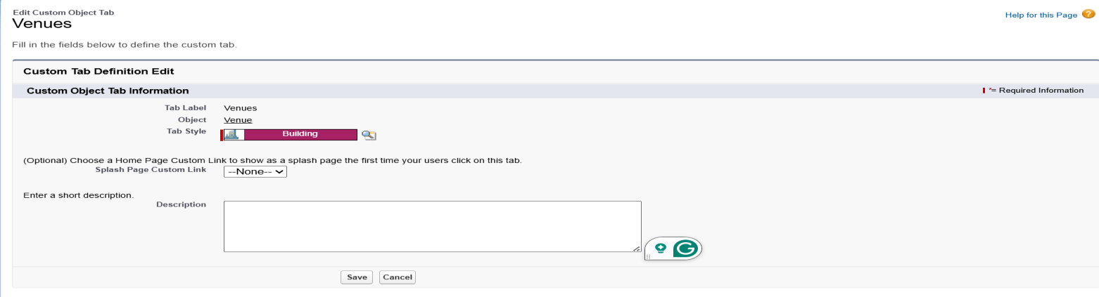

**Activity 1: Create a tab for Venue Object**

1. Go to Setup page >> type tabs in Quick Find box.
2. Click on tabs >> Click on New (under custom object tab).
3. Select Object (Venue) >> Select the tab style.
4. Next (Add to profiles page), keep it as default >> Next (Add to Custom App), uncheck the include tab.
5. Make sure that the Append tab user’s existing personal customizations is checked.
6. Click on Save.

# Activity 2: Create a tab for Drop-Off Point

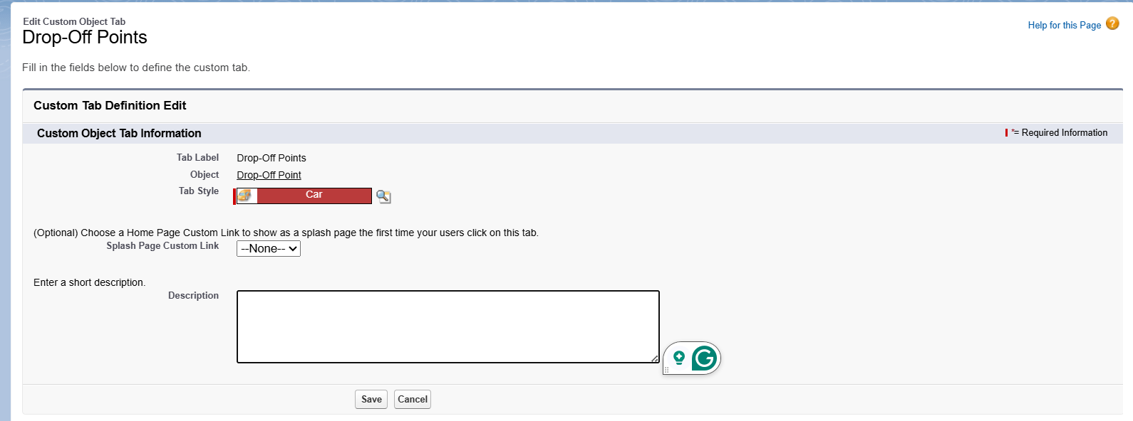

1. Go to Setup page >> type tabs in Quick Find box.
2. Click on tabs >> Click on New (under custom object tab).

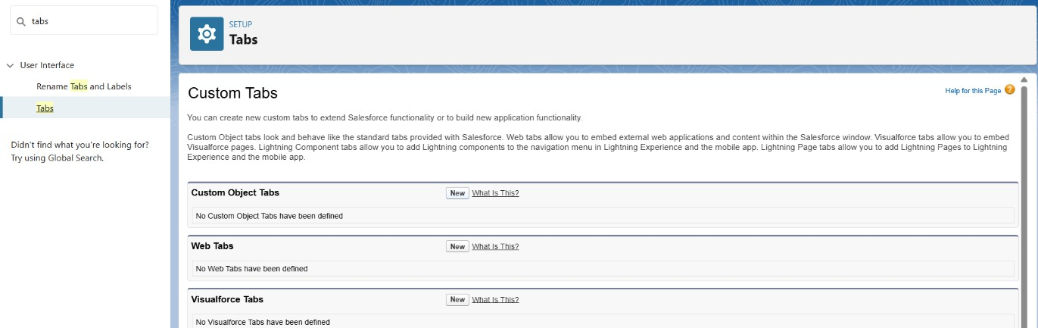

1. Select Object (Drop-Off Point) >> Select the tab style.
2. Next (Add to profiles page), keep it as default >> Next (Add to Custom App), uncheck the include tab.
3. Make sure that the Append tab user’s existing personal customizations is checked.
4. Click on Save.

# Activity 3: Create a tab for Task Object

1. Go to Setup page >> type tabs in Quick Find box.
2. Click on tabs >> Click on New (under custom object tab).

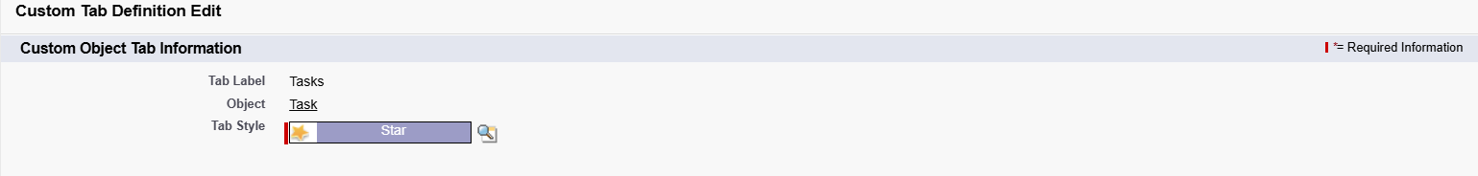

1. Select Object(Task) >> Select tab style.



1. Next (Add to profiles page), keep it as default >> Next (Add to Custom App), uncheck the include tab.
2. Make sure that the Append tab user’s existing personal customizations is checked.
3. Click on Save.

# Activity 4: Create tab for Volunteer Object

* 1. Go to the Setup page >> type tabs in Quick Find box.
  2. Click on tabs >> Click on New (under custom object tab).



* 1. Select Object(Volunteer) >> Select tab style.

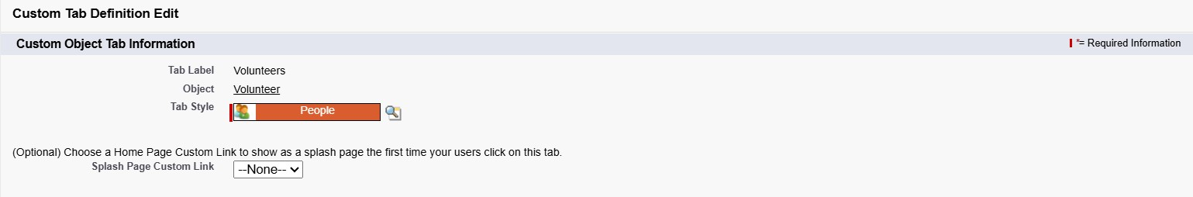

* 1. Next (Add to profiles page), keep it as default >> Next (Add to Custom App), uncheck the include tab.
  2. Make sure that Append tab user’s existing personal customizations is checked.
  3. Click on Save.

# Activity 5: Create a tab for Execution Detail

1. Go to Setup page >> type tabs in Quick Find box.
2. Click on tabs >> Click on New (under custom object tab).



1. Select Object(Execution Detail) >> Select tab style.

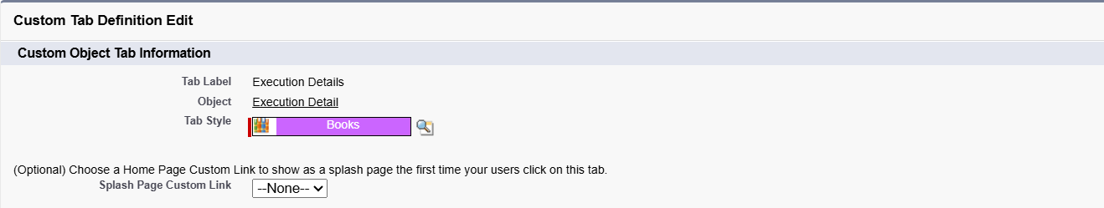

1. Next (Add to profiles page), keep it as default >> Next (Add to Custom App), uncheck the include tab.
2. Make sure that Append tab user’s existing personal customizations is checked.
3. Click on Save.

**Output:**

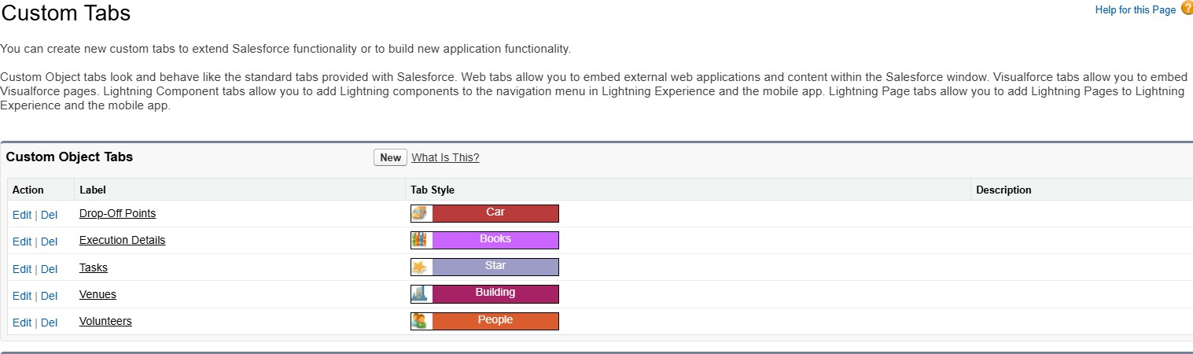

**Milestone – 4 The Lightning App**

**Activity 1: Create a Lightning app**

1. Go to Setup page >> Search “App Manager” in Quick Find box.
2. Select “App Manager” >> Click on New lightning App.

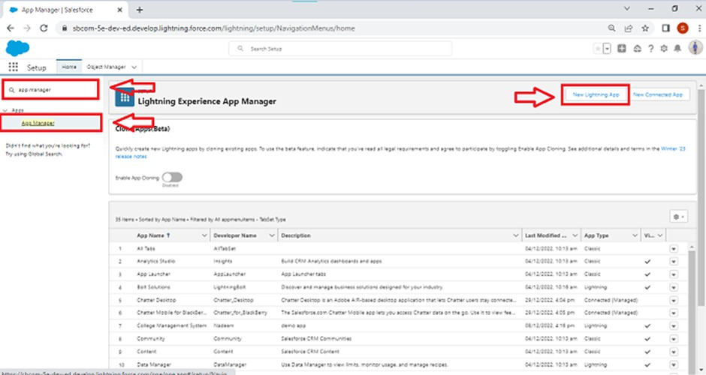

1. Fill the app name in app details and branding as follow.
   * App Name: **Food Connect**.
   * Developer Name: **FoodConnect**.
   * Image: Click on Upload image and add the image related to Supply leftover food to Poor.

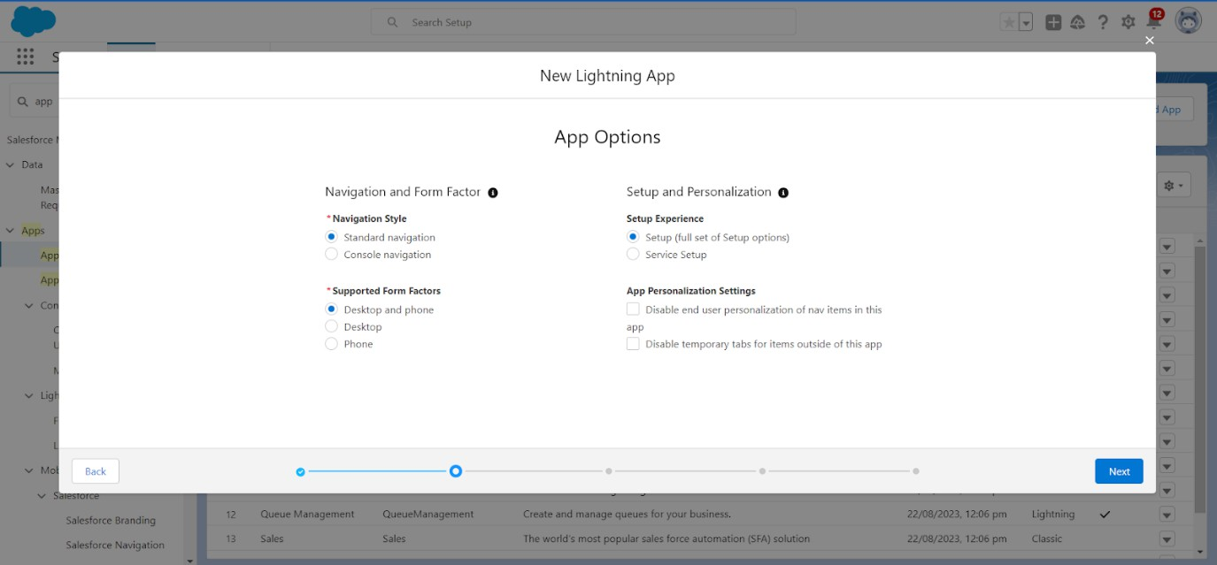

1. Click on Next >> {App option page)Set Navigation Style as Standard Navigation >> Click on Next.
2. In (Utility Items), keep it as default >> Next.
3. Add Navigation items:

Search for items in search bar(Home, Venues, Tasks, Drop-Off Points, Execution Details, Reports, Volunteer, Dashboards), and move it to the Selected Items.

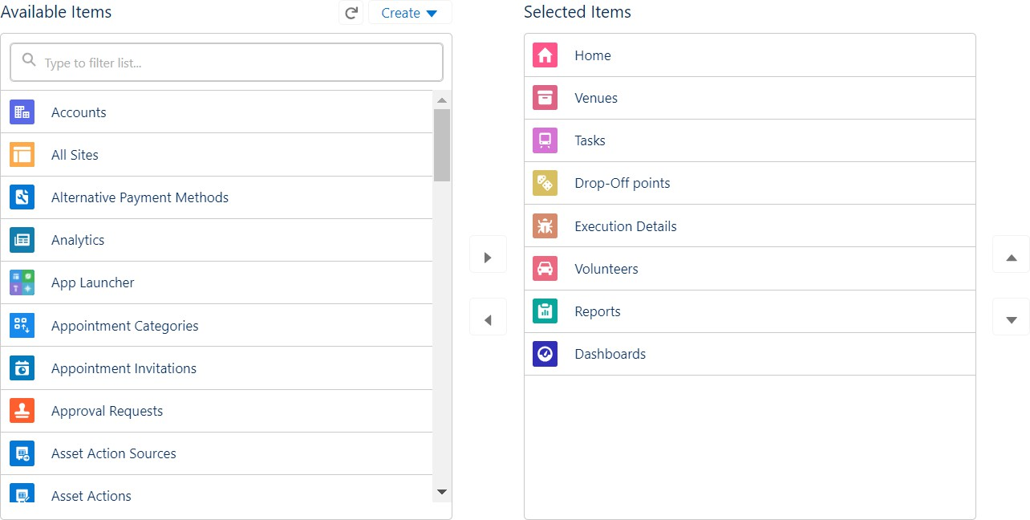

1. To Add User Profiles:

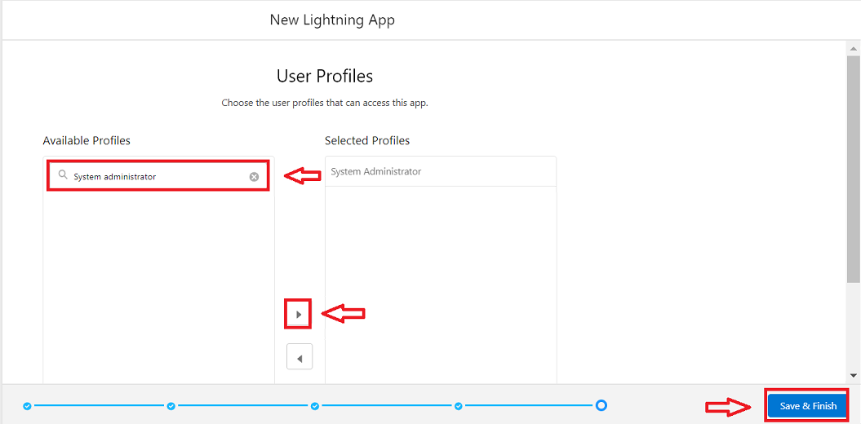

Search Profile (System Administrator ) in the search bar >> Click on arrow button >> Save & Finish.

# Milestone – 5 Fields

**Activity 1: Creation of Relationship Fields in Objects. Creation of Lookup Relationship on Volunteer Object**

1. Go to Setup >> Click on Object Manager
2. Type object name (Volunteer) in the search bar >> Click on the object.

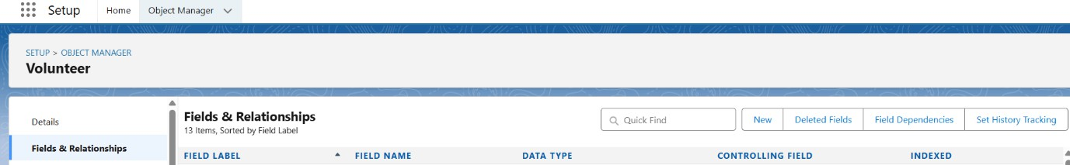

1. Now, Click on Fields & Relationships >> Click on New.
2. Select Lookup Relationship.

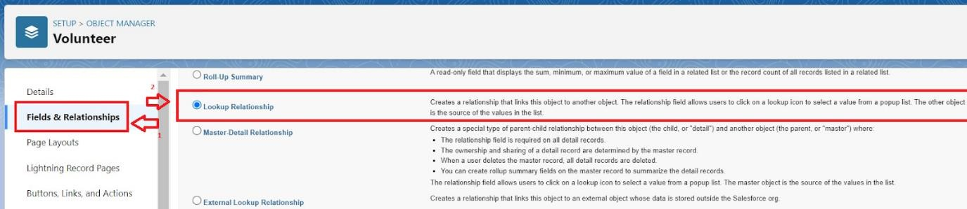

1. Select the related object “Drop-Off Point” and click on next.

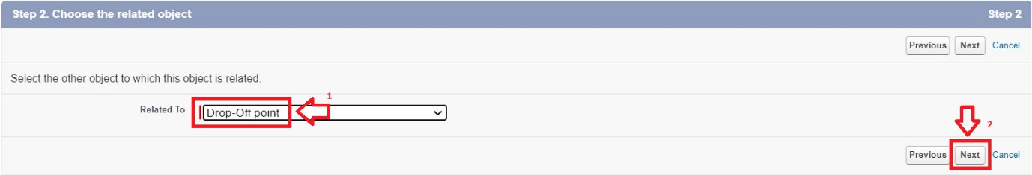

1. Field Name: **Drop-Off Point**. Field label: **Drop-Off Point**.

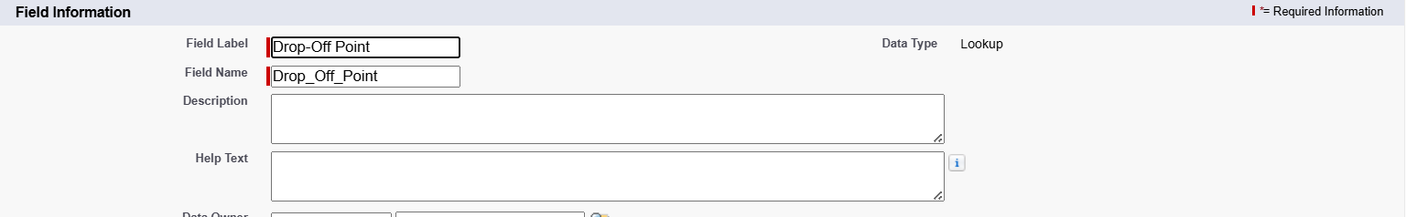

1. Click on Next >> Next >> Save.

# Creation of Master Detail Relationship Field on Execution Details Object:

1. Go to Setup >> Click on Object Manager
2. Type object name (Execution Details) in the search bar >> Click on the object.

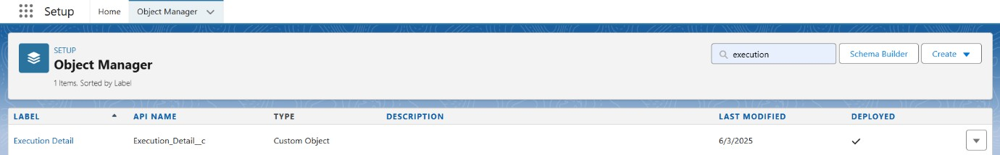

1. Now, Click on Fields & Relationships >> Click on New.
2. Select Master Detail Relationship.

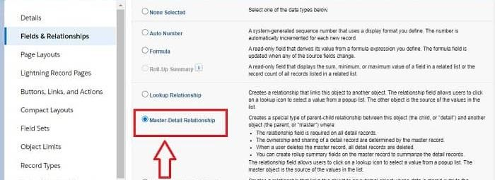

1. Select the related object “Volunteer” and click on next.

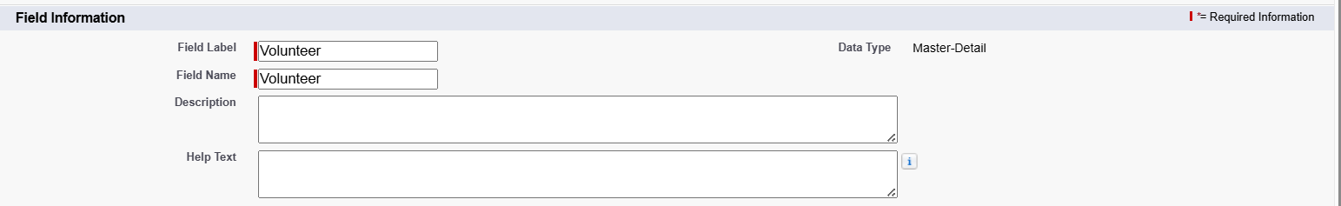

1. Field Name: **Volunteer**. Field label: **Volunteer**.
2. Click on Next >> Next >> Save.

# Creation of Master Detail Relationship on Execution Details object.

1. Go to Setup >> Click on Object Manager
2. Type object name (Execution Details) in the search bar >> Click on the object.



1. Now, Click on Fields & Relationships >> Click on New.
2. Select Master Detail Relationship.



1. Select the related object “Task” and click on next.

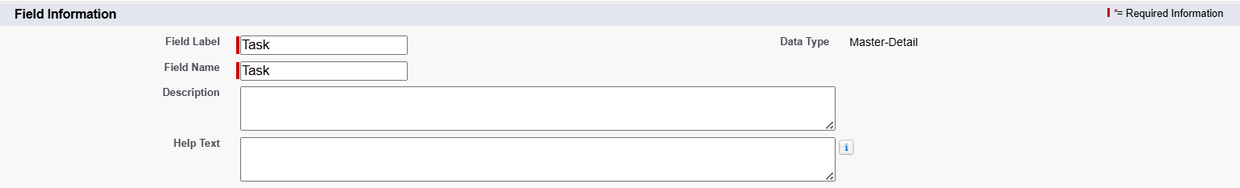

1. Field Name: **Task**. Field label: **Task**.
2. Click on Next >> Next >> Save.

# Creation of Lookup Relationship Field on Drop-Off Point Object:

1. Go to Setup >> Click on Object Manager
2. Type object name (Drop-Off Point) in the search bar >> Click on the object.

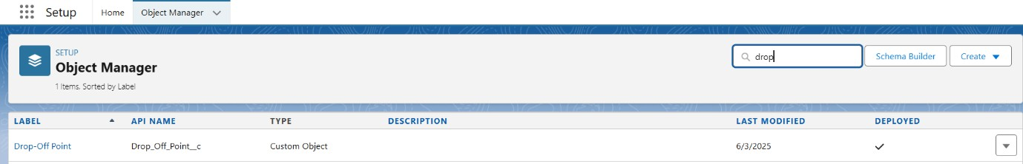

1. Now, Click on Fields & Relationships >> Click on New.
2. Select Lookup Relationship.



1. Select the related object “Venue” and click on next.

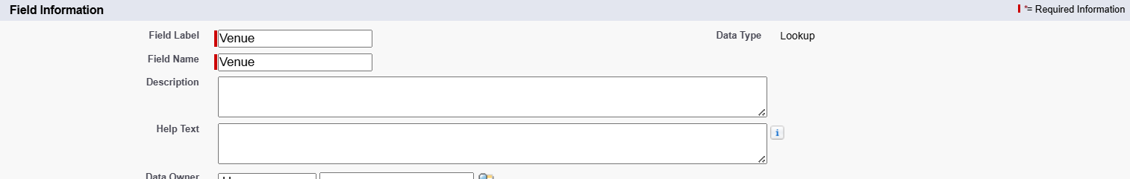

1. Field Name: **Venue**. Field label: **Venue**.
2. Click on Next >> Next >> Save.

# Creation of Lookup Relationship Field on Task Object:

1. Go to Setup >> Click on Object Manager
2. Type object name (Task) in the search bar >> Click on the object.

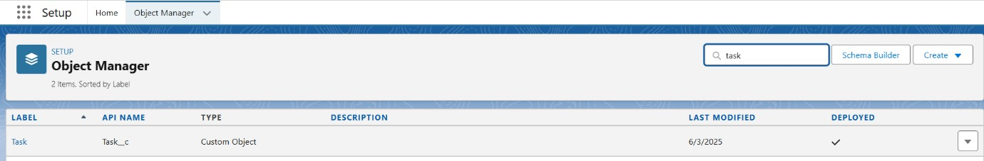

1. Now, Click on Fields & Relationships >> Click on New.
2. Select Lookup Relationship.

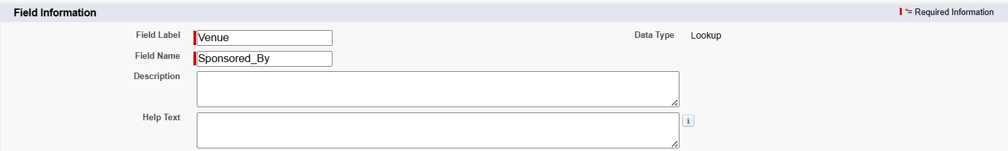

1. Select the related object “Venue” and click on next.
2. Field Name: **Sponsored By**. Field label: **Venue**.
3. Click on Next >> Next >> Save.

# Creation of Lookup Relationship Field on Task Object:

1. Go to Setup >> Click on Object Manager
2. Type object name (Task) in the search bar >> Click on the object.



1. Now, Click on Fields & Relationships >> Click on New.
2. Select Lookup Relationship.



1. Select the related object “Drop-Off Point” and click on next.

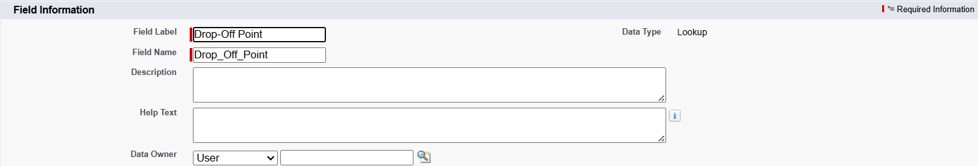

1. Field Name: **Drop-Off Point**. Field label: **Drop-off Point**.
2. Click on Next >> Next >> Save.

# Activity 2: Creation of Fields for the Venue Object: Create a “Contact Email” Field in Venue object.

1. Go to Setup page >> Click on Object Manager.
2. Type Object name (Venue) in search bar >> Click on the object.

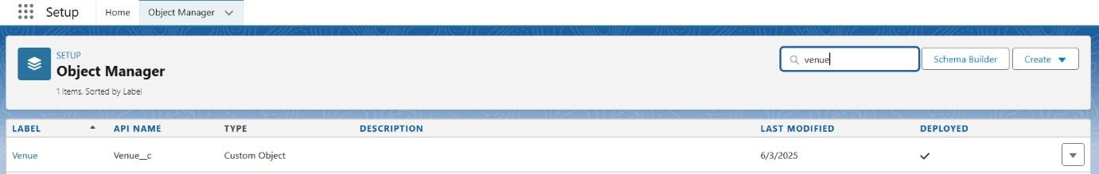

1. Now, Click on “Fields & Relationships” >> Click on New.
2. Select Datatype as “Email” and click on Next.

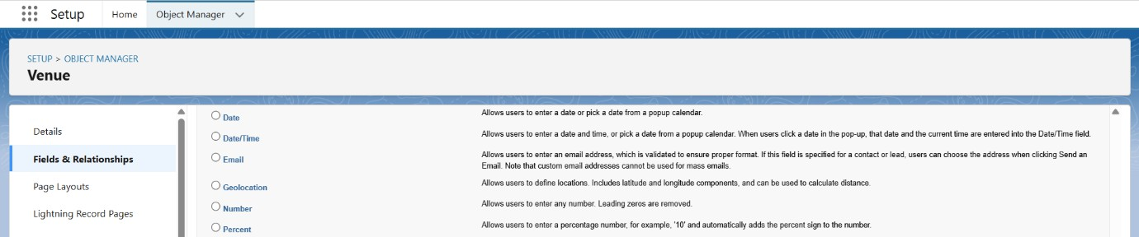

1. Fill in the Above as follows:
   * Field Label: **Contact Email**.
   * Field Name: **Contact Email**.
   * Click on the Required checkbox.
   * Click on Next >> Next >> Save and New.

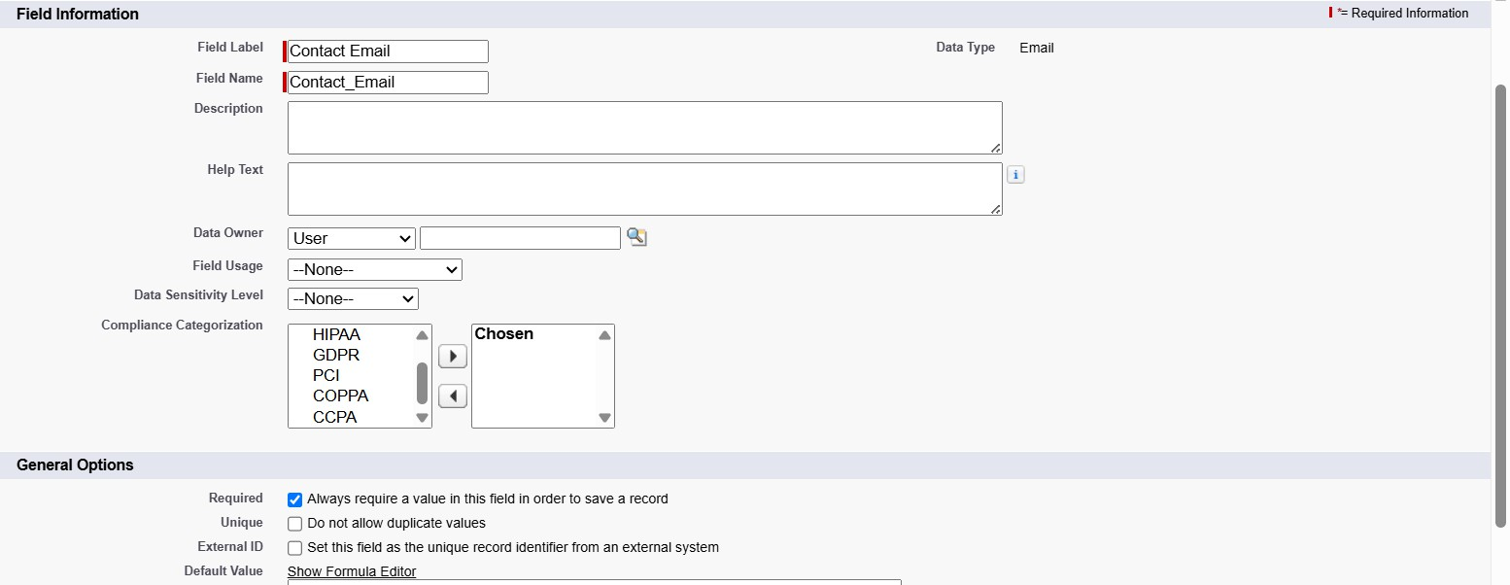

# Create a “Contact Phone” Field in Venue Object.

1. Go to Setup page >> Click on Object Manager.
2. Type Object name (Venue) in search bar >> Click on the object.



1. Now, Click on “Fields & Relationships” >> Click on New.
2. Select Datatype as “Phone” and click on Next.

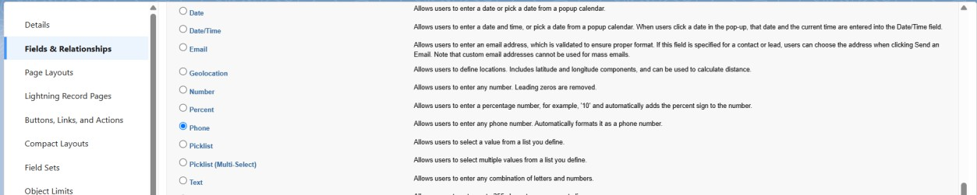

1. Fill in the Above as follows:
   * Field Label: **Contact Phone**.
   * Field Name: **Contact Phone**.
   * Click on the Required checkbox.
   * Click on Next >> Next >> Save and New.

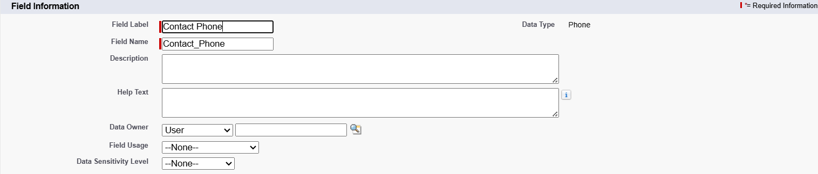

# Create a “Location” Field in Venue Object.

1. Go to Setup page >> Click on Object Manager.
2. Type Object name (Venue) in search bar >> Click on the object.



1. Now, click on “Fields & Relationships” >> Click on New.
2. Select Datatype as “Geolocation” and click on Next.

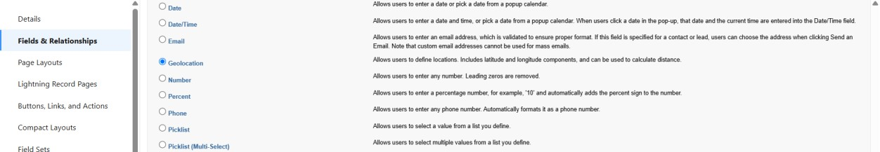

1. Fill in the Above as follows:
   * Field Label: **Location**.
   * Decimal Places: 4
   * Field Name: **Location**.
   * Description: Enter the Geolocation of your Venue.
   * Click on Next >> Next >> Save and New.

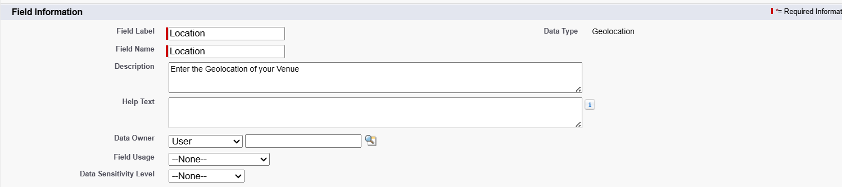

# Create a “Venue Location” Field on Venue Object.

1. Go to Setup page >> Click on Object Manager.
2. Type Object name (Venue) in search bar >> Click on the object.



1. Now, click on “Fields & Relationships” >> Click on New.
2. Select Datatype as “Long Text Area” and click on Next.

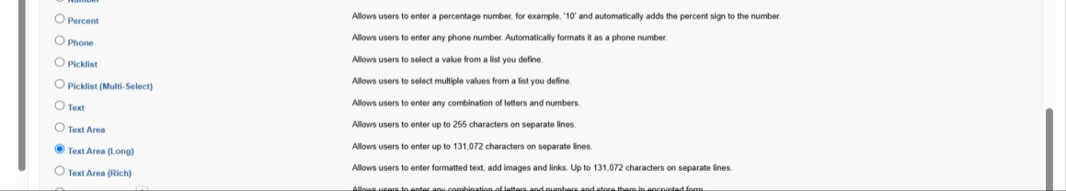

1. Fill in the Above as follows:
   * Field Label: **Venue Location**.
   * Field Name: **Venue Location**.
   * Click on Next >> Next >> Save and New.

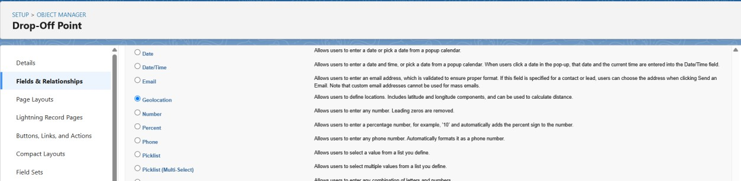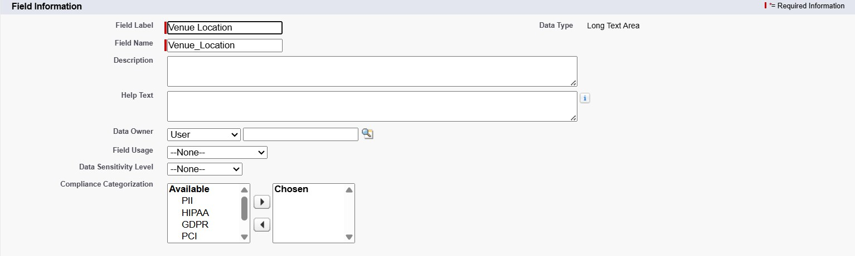

# Activity 3: Creation of Fields for the Drop-Off Point Object. Create a “Location 2” field on Drop-Off Object

1. Go to Setup page >> Click on Object Manager.
2. Type Object name (Drop-Off Point) in search bar >> Click on the object.

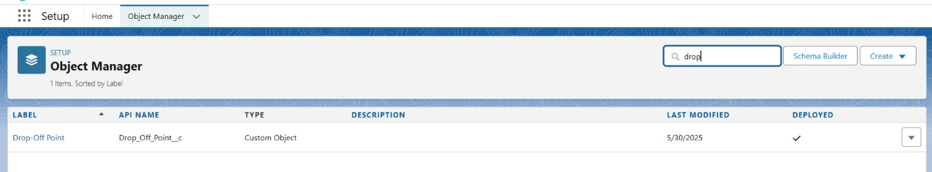

1. Now, click on “Fields & Relationships” >> Click on New.
2. Select Datatype as “Geolocation” and click on Next.
3. Fill in the Above as follows:
   * Field Label: **Location 2**.
   * Field Name: **Location_2**.
   * Description: Enter the Geolocation of the Drop-Off Point.
   * Geolocation Options: Select Decimal

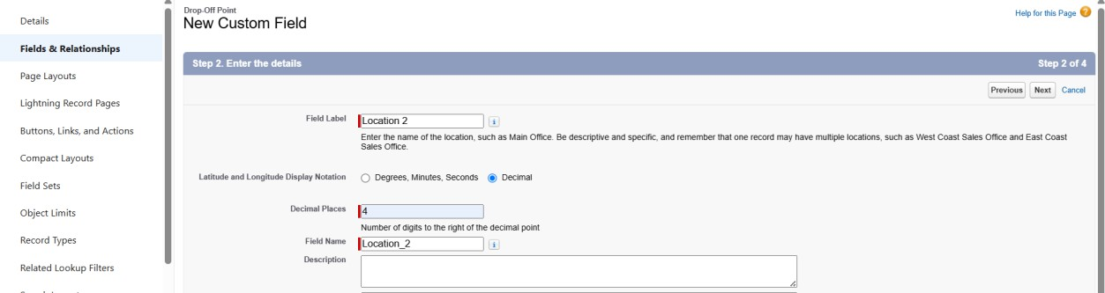

* + Decimal Places: 4

1. Click on Next >> Next >> Save and New.

# Create a “distance calculation” field on Drop-Off Object

1. Go to Setup page >> Click on Object Manager.
2. Type Object name (Drop-Off Point) in search bar >> Click on the object.



1. Now, click on “Fields & Relationships” >> Click on New.
2. Select Datatype as “Formula” and click on Next.

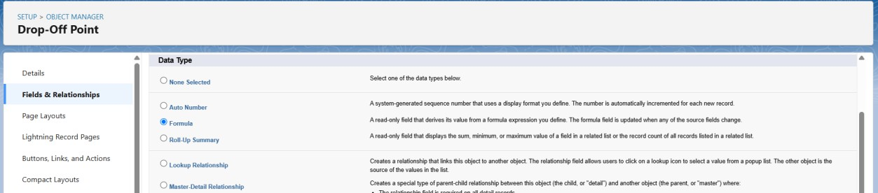

1. Fill in the Above as follows:
   * Field Label: **distance calculation**.
   * Field Name: **distance_calculation**.
   * Formula Return Type: Number.

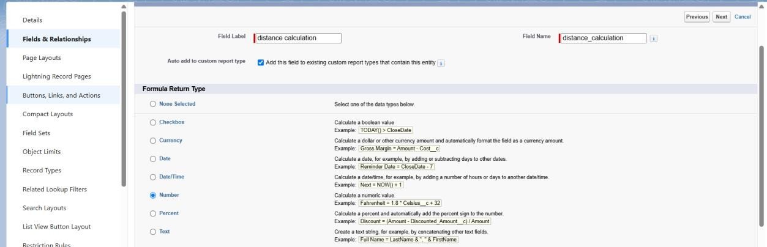

1. Click on Next >> Click on Advanced Formula.
   * Formula: DISTANCE( Location_2 c , Venue r.Location c , 'km')

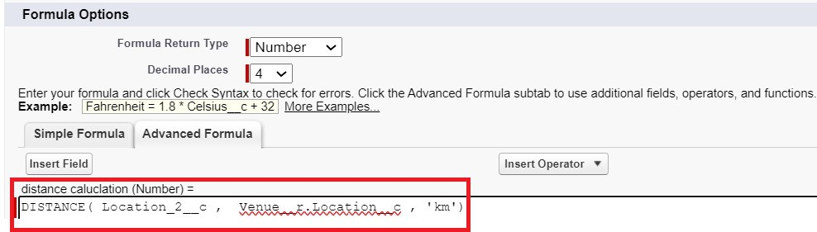

1. Click on Next >> Next >> Save and New.

# Create a “State” Field in Drop-Off Point Object.

1. Go to Setup page >> Click on Object Manager.
2. Type Object name (Drop-Off Point) in search bar >> Click on the object.



1. Now, click on “Fields & Relationships” >> Click on New.
2. Select Datatype as “Picklist” and click on Next.

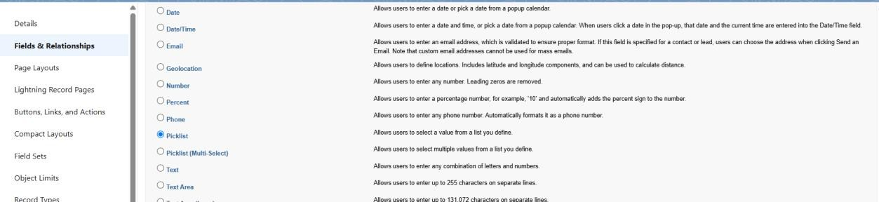

1. Fill in the Above as follows:
   * Field Label: **State**.
   * Field Name: **State**.
   * Enter values, with each value separated by a new line:

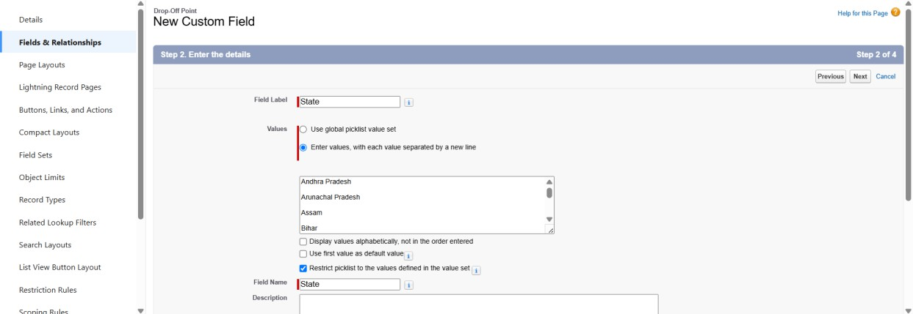

Andhra Pradesh Arunachal Pradesh Assam

Bihar Chhattisgarh Goa

Gujarat Haryana

Himachal Pradesh Jharkhand Karnataka

Kerala

Maharashtra Madhya Pradesh Manipur Meghalaya Mizoram Nagaland Odisha

Punjab Rajasthan Sikkim Tamil Nadu Tripura Telangana

Uttar Pradesh Uttarakhand West Bengal

Andaman & Nicobar (UT) Chandigarh (UT)

Dadra & Nagar Haveli and Daman & Diu (UT) Delhi [National Capital Territory (NCT)] Jammu & Kashmir (UT)

Ladakh (UT) Lakshadweep (UT) Puducherry (UT)

1. Click on Required check box.
2. Click on Next >> Next >> Save and New.

# Create a “Distance” Field on Drop-Off Point Object.

1. Go to Setup page >> Click on Object Manager.
2. Type Object name (Drop-Off Point) in the search bar >> Click on the object.



1. Now, click on “Fields & Relationships” >> Click on New.
2. Select Datatype as “Number” and click on Next.

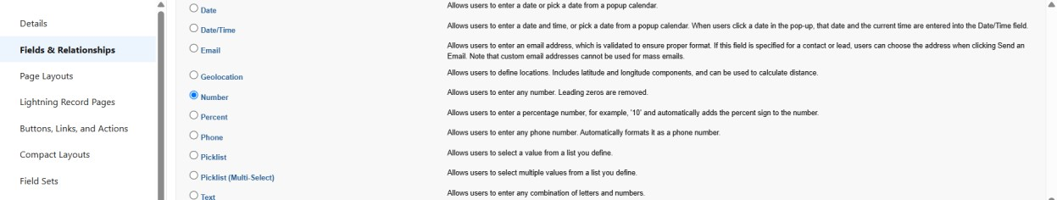

1. Fill in the Above as follows:
   * Field Label: **Distance**.
   * Field Name: **Distance**.
   * Length: 14
   * Decimal Places: 4
   * Click on required check box.
   * Click on Next >> Next >> Save.

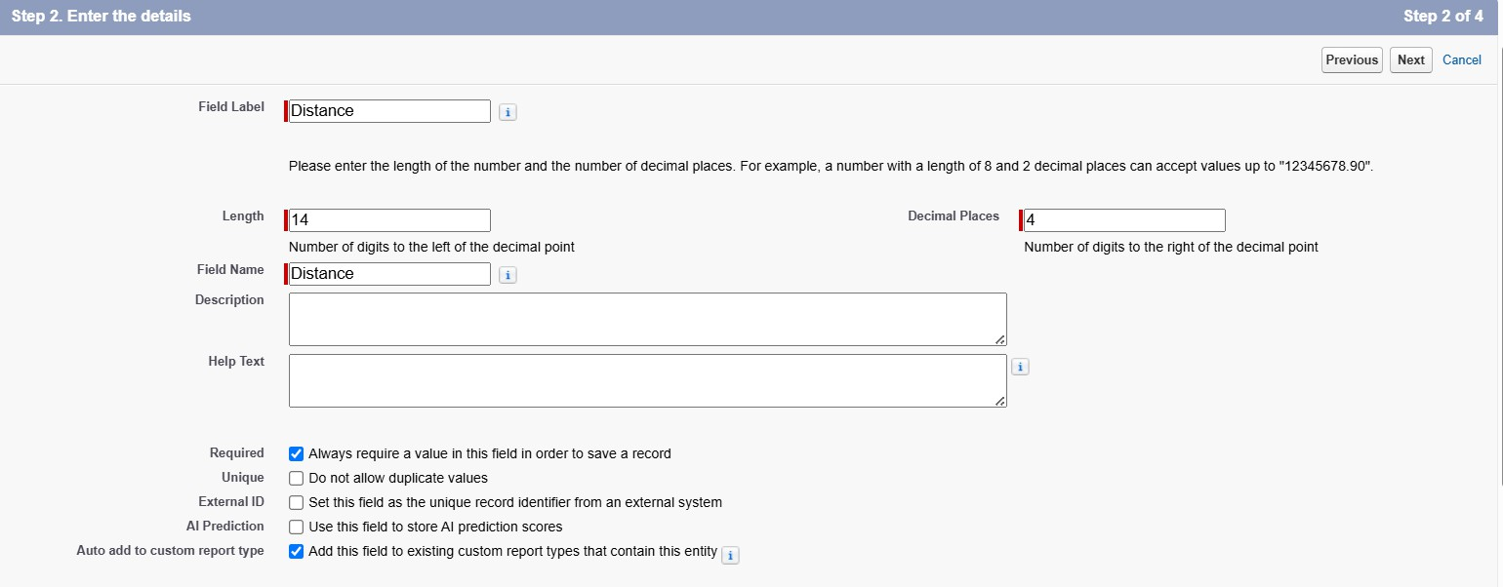

# Activity 4: Creation of Fields for the Task object. Create a “Task ID” field in task object:

1. Go to Setup page >> Click on Object Manager.
2. Type Object name (Task) in the search bar >> Click on the object.

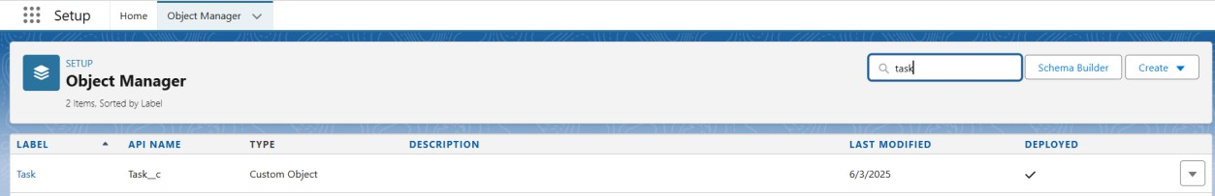

1. Now, click on “Fields & Relationships” >> Click on New.
2. Select Datatype as “Auto Number” and click on Next.

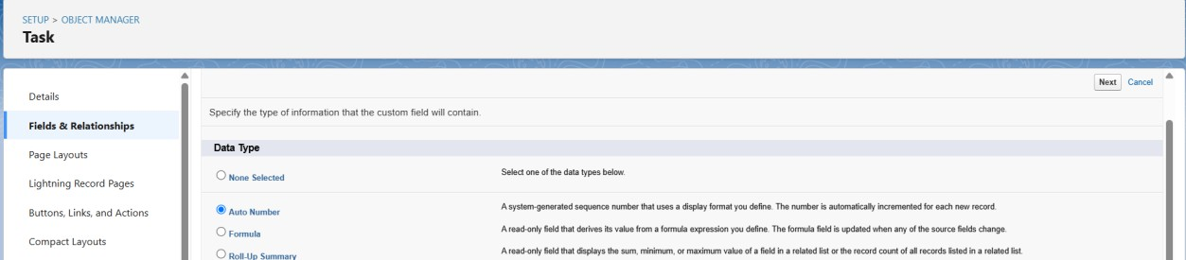

1. Fill in the Above as follows:
   * Field Label: **Task ID**.
   * Field Name: **Task_ID**.
   * Display Format: TASK{0}
   * Starting Number: 1
   * Click on required check box.
2. Click on Next >> Next >> Save and New.

# Create a “Date” field in task object:

1. Go to Setup page >> Click on Object Manager.
2. Type Object name (Task) in the search bar >> Click on the object.



1. Now, click on “Fields & Relationships” >> Click on New.
2. Select Datatype as “Date” and click on Next.

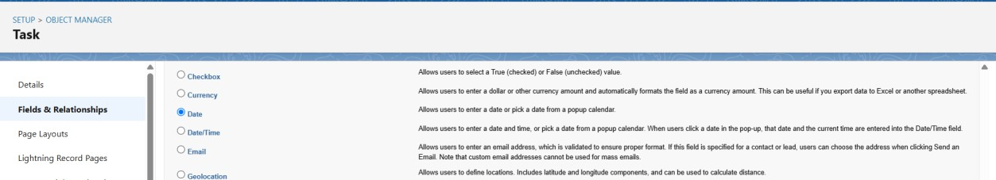

1. Fill in the Above as follows:
   * Field Label: **Date**.
   * Field Name: **Date**.
   * Click on the required check box.

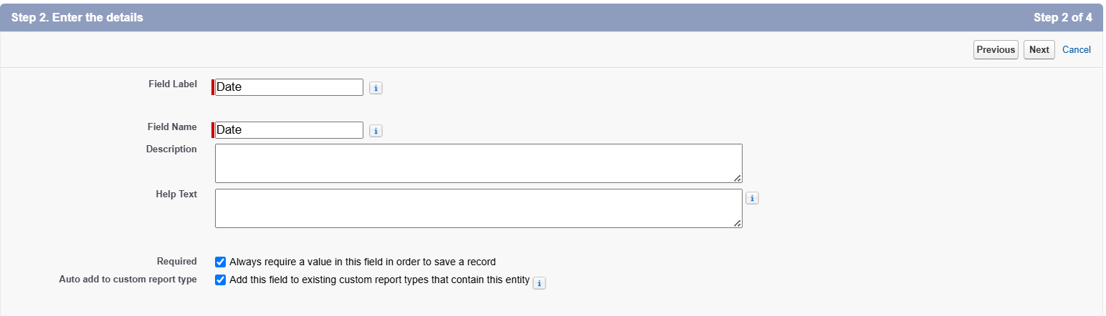

1. Click on Next >> Next >> Save and New.

# Create a “Food Category” field in task object:

1. Go to Setup page >> Click on Object Manager.
2. Type Object name (Task) in the search bar >> Click on the object.



1. Now, click on “Fields & Relationships” >> Click on New.
2. Select Datatype as “Picklist(Multiselect)” and click on Next.

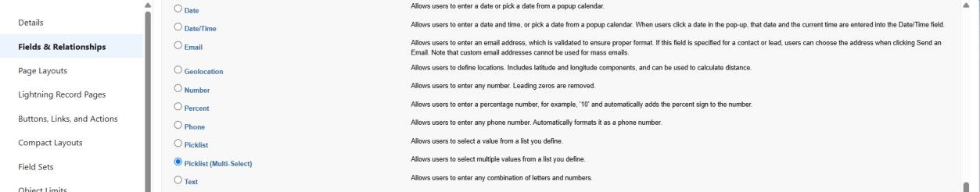

1. Fill in the Above as follows:
   * Field Label: **Food Category**.
   * Field Name: **Food_Category**.
   * Enter values, with each value separated by a new line: Veg

Non-Veg Salad Snack

* + Click on the required check box.

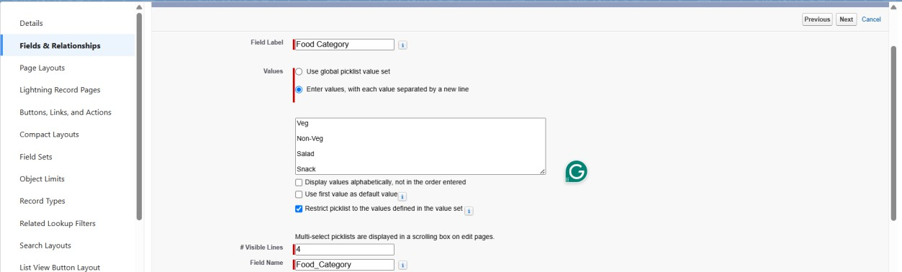

1. Click on Next >> Next >> Save and New.

# Create a “Number of People Served” field in task object:

1. Go to Setup page >> Click on Object Manager.
2. Type Object name (Task) in the search bar >> Click on the object.



1. Now, click on “Fields & Relationships” >> Click on New.
2. Select Datatype as “Number” and click on Next.



1. Fill in the Above as follows:
   * Field Label: **Number of People Served**.
   * Field Name: **Number_of_People_Served**.
   * Click on the required check box.

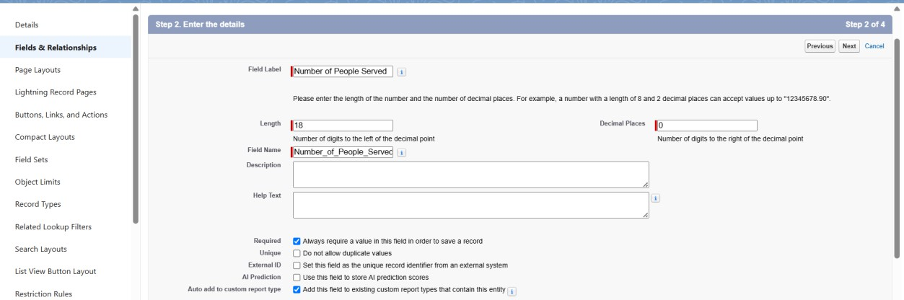

1. Click on Next >> Next >> Save and New.

# Create a “Name of the Person” field in task object:

1. Go to Setup page >> Click on Object Manager.
2. Type Object name (Task) in the search bar >> Click on the object.



1. Now, click on “Fields & Relationships” >> Click on New.
2. Select Datatype as “Text” and click on Next.

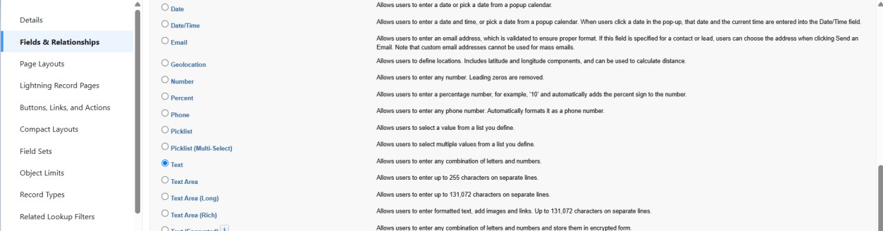

1. Fill in the Above as follows:
   * Field Label: **Number of the Person**.
   * Field Name: **Number_of_the_Person**.

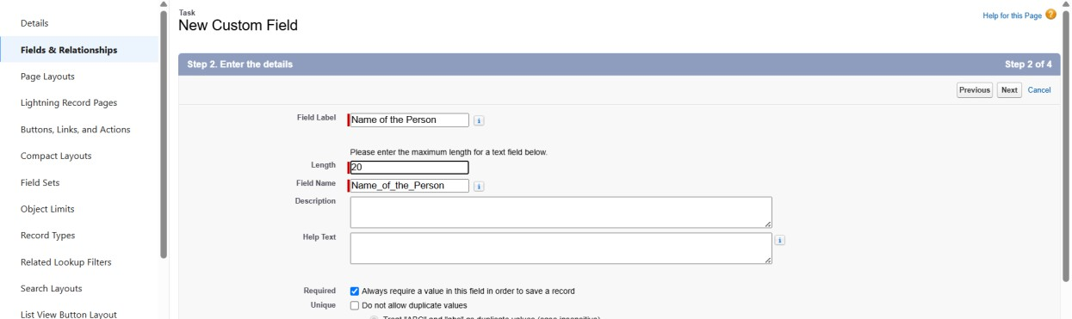

1. Click on Next >> Next >> Save and New.

# Create a “Phone” field in task object:

1. Go to Setup page >> Click on Object Manager.
2. Type Object name (Task) in the search bar >> Click on the object.



1. Now, click on “Fields & Relationships” >> Click on New.
2. Select Datatype as “Phone” and click on Next.

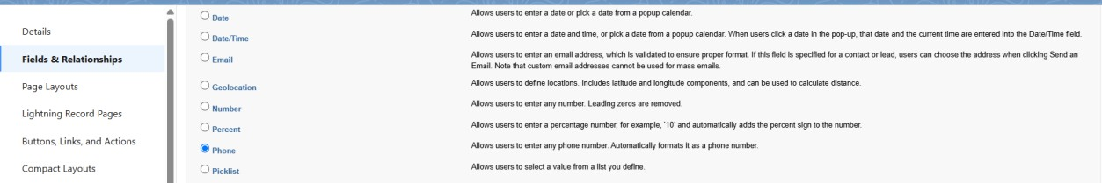

1. Fill in the Above as follows:
   * Field Label: **Phone**.
   * Field Name: **Phone**.

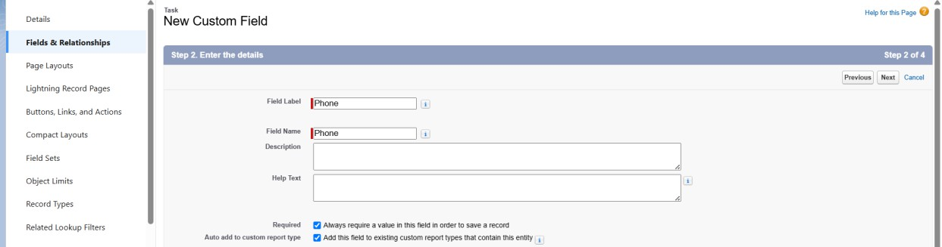

1. Click on Next >> Next >> Save and New.

# Create a “Rating” field in task object:

1. Go to Setup page >> Click on Object Manager.
2. Type Object name (Task) in the search bar >> Click on the object.



1. Now, click on “Fields & Relationships” >> Click on New.
2. Select Datatype as “Picklist” and click on Next.



1. Fill in the Above as follows:
   * Field Label: **Rating**.
   * Field Name: **Rating**.
   * Enter values, with each value separated by a new line: 1

2

3

4

5

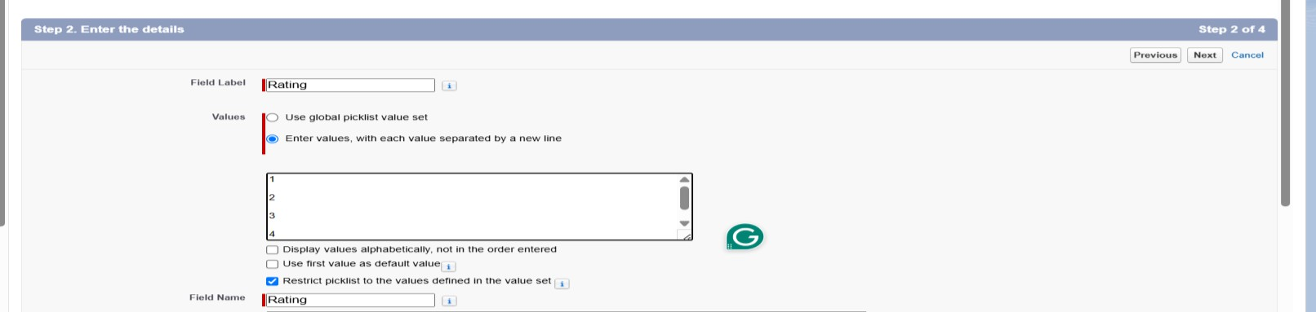

1. Click on Next >> Next >> Save and New.

# Create a “Feedback” field in task object:

1. Go to Setup page >> Click on Object Manager.
2. Type Object name (Task) in the search bar >> Click on the object.



1. Now, click on “Fields & Relationships” >> Click on New.
2. Select Datatype as “Long Text Area” and click on Next.

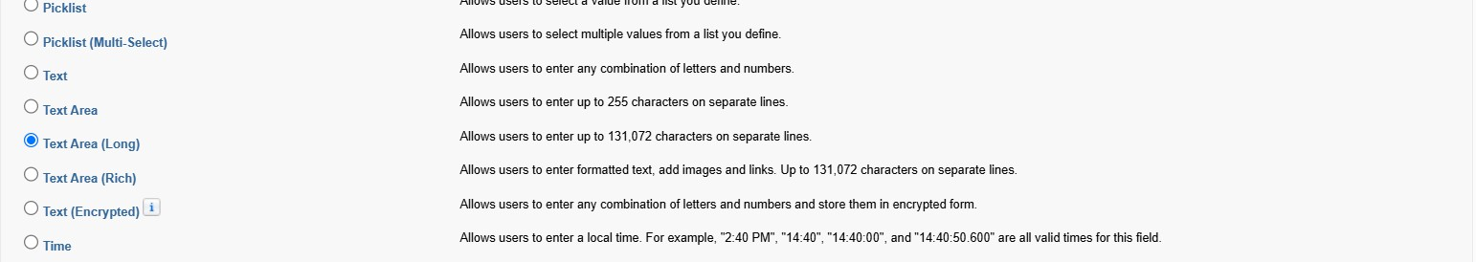

1. Fill in the Above as follows:
   * Field Label: **Feedback**.
   * Field Name: **Feedback**.

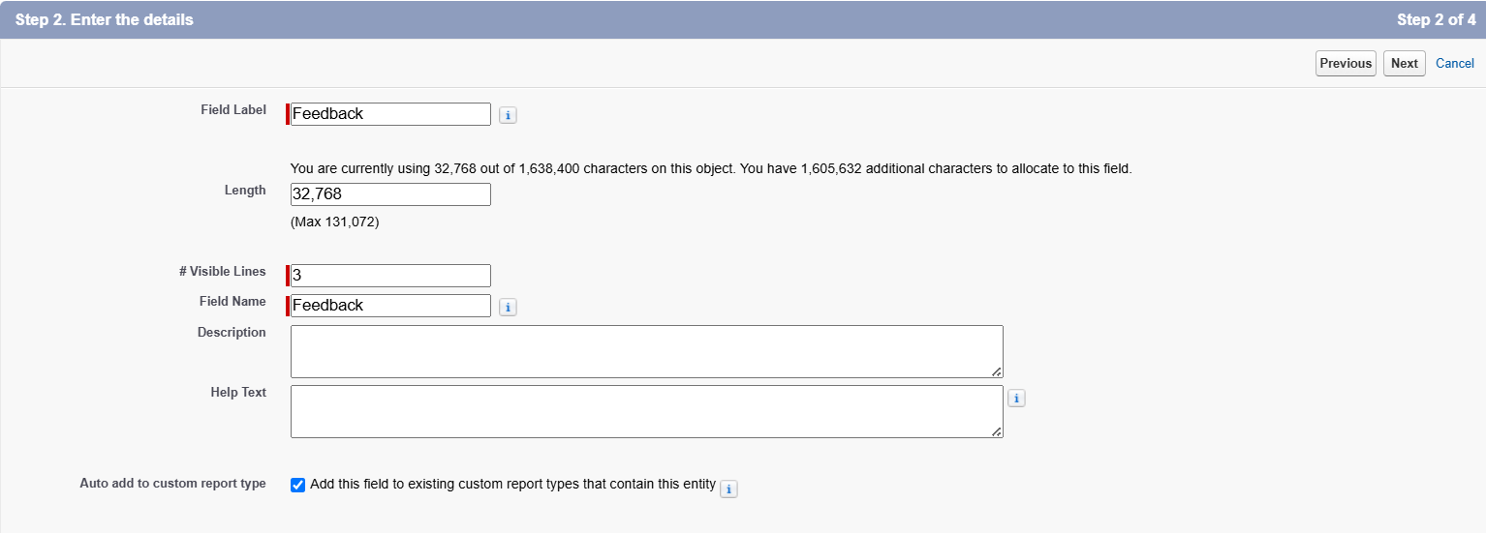

1. Click on Next >> Next >> Save and New. **Activity 5: Creation of fields for the Volunteer Object**. **Create “Volunteer ID” field in Volunteer object:**
2. Go to Setup page >> Click on Object Manager.
3. Type Object name (Volunteer) in the search bar >> Click on the object.

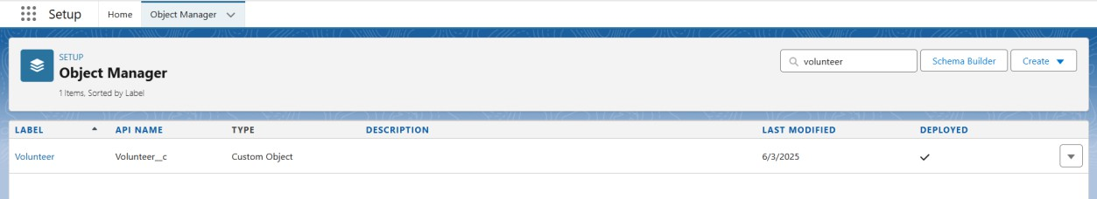

1. Now, click on “Fields & Relationships” >> Click on New.
2. Select Datatype as “Auto Number” and click on Next.



1. Fill in the Above as follows:
   * Field Label: **Volunteer ID**.
   * Field Name: **Volunteer_ID**.

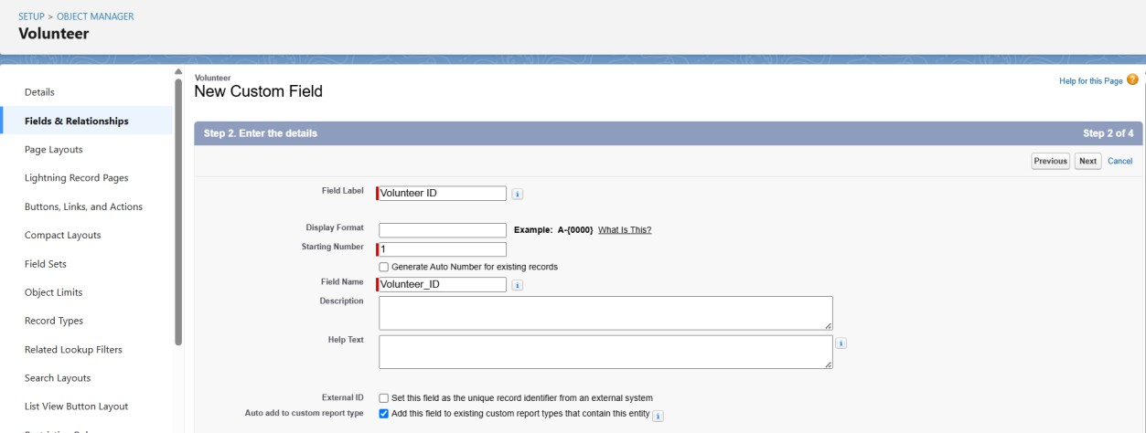

1. Click on Next >> Next >> Save and New.

# Create “Gender” field in Volunteer object:

1. Go to Setup page >> Click on Object Manager.
2. Type Object name (Volunteer) in the search bar >> Click on the object.



1. Now, click on “Fields & Relationships” >> Click on New.
2. Select Datatype as “Picklist” and click on Next.



1. Fill in the Above as follows:
   * Field Label: **Gender**.
   * Field Name: **Gender**.
   * Enter values, with each value separated by a new line: Female

Male

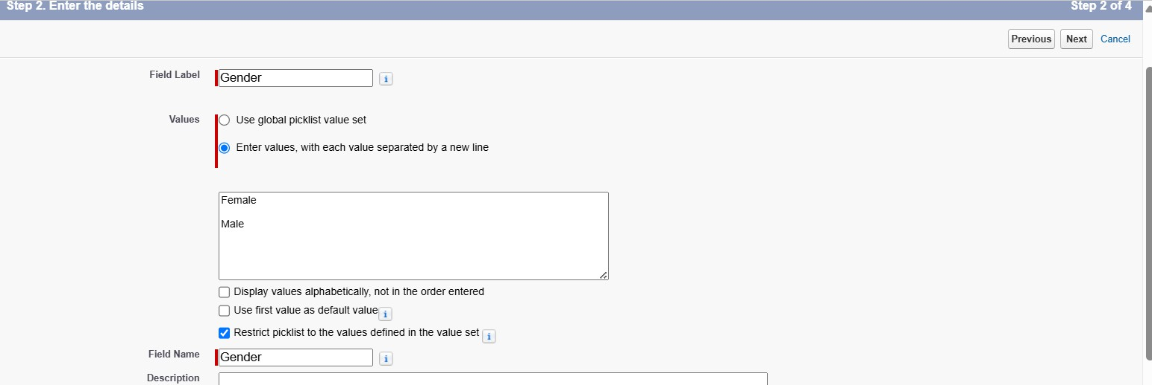

1. Click on Next >> Next >> Save and New.

# Create “Available On” field in Volunteer object:

1. Go to Setup page >> Click on Object Manager.
2. Type Object name (Volunteer) in the search bar >> Click on the object.



1. Now, click on “Fields & Relationships” >> Click on New.
2. Select Datatype as “Date” and click on Next.



1. Fill in the Above as follows:
   * Field Label: **Available On**.
   * Field Name: **Available_On**.
   * Click on required check box.

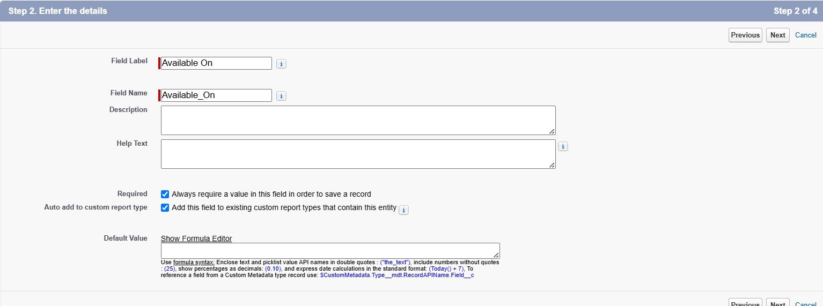

1. Click on Next >> Next >> Save and New.

# Create “Age” field in Volunteer object:

1. Go to Setup page >> Click on Object Manager.
2. Type Object name (Volunteer) in the search bar >> Click on the object.



1. Now, click on “Fields & Relationships” >> Click on New.
2. Select Datatype as “Number” and click on Next.



1. Fill in the Above as follows:
   * Field Label: **Age**.
   * Field Name: **Age**.
   * Click on required check box.

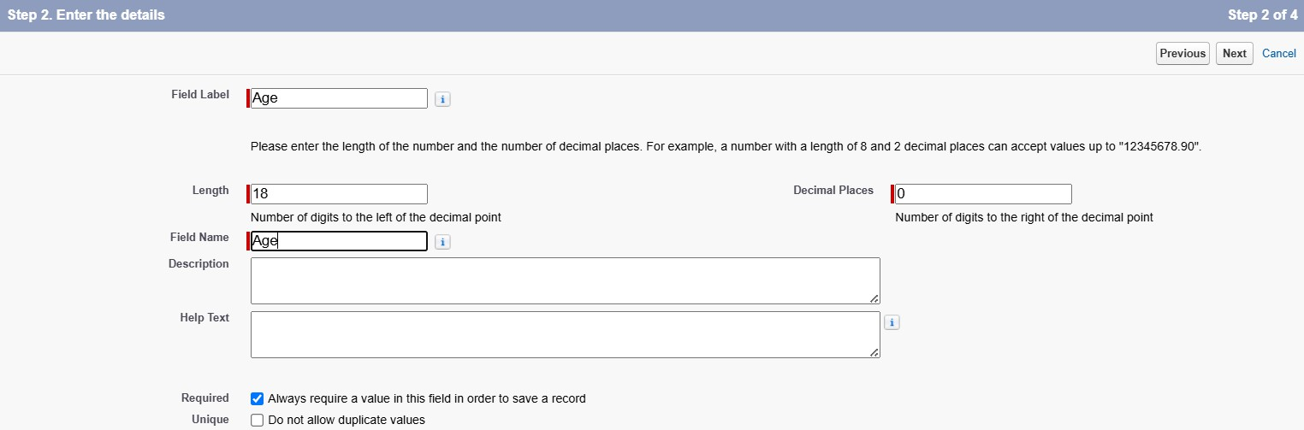

1. Click on Next >> Next >> Save and New.

# Create “Email” field in Volunteer object:

1. Go to Setup page >> Click on Object Manager.
2. Type Object name (Volunteer) in the search bar >> Click on the object.



1. Now, click on “Fields & Relationships” >> Click on New.
2. Select Datatype as “Email” and click on Next.

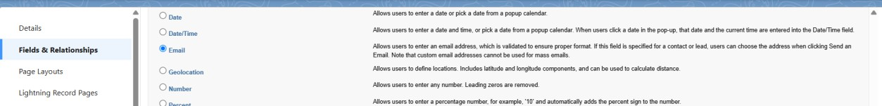

1. Fill in the Above as follows:
   * Field Label: **Email**.
   * Field Name: **Email**.
   * Click on required check box.

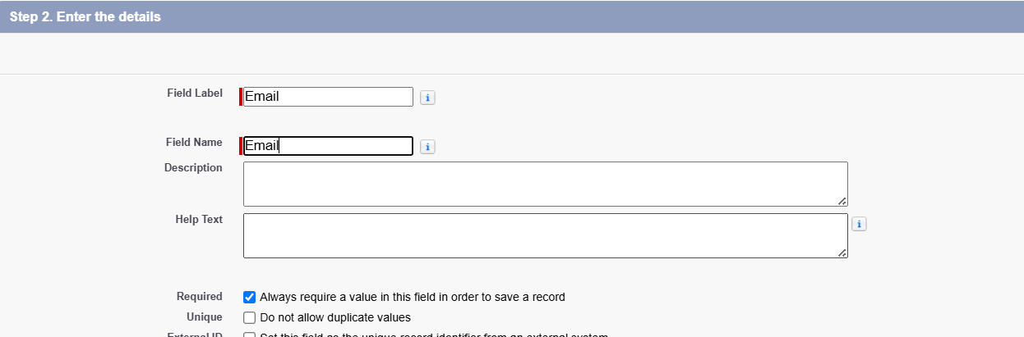

1. Click on Next >> Next >> Save and New.

# Create “Contact Number” field in Volunteer object:

1. Go to Setup page >> Click on Object Manager.
2. Type Object name (Volunteer) in the search bar >> Click on the object.



1. Now, click on “Fields & Relationships” >> Click on New.
2. Select Datatype as “Auto Number” and click on Next.



1. Fill in the Above as follows:
   * Field Label: **Contact Number**.
   * Field Name: **Contact_Number**.

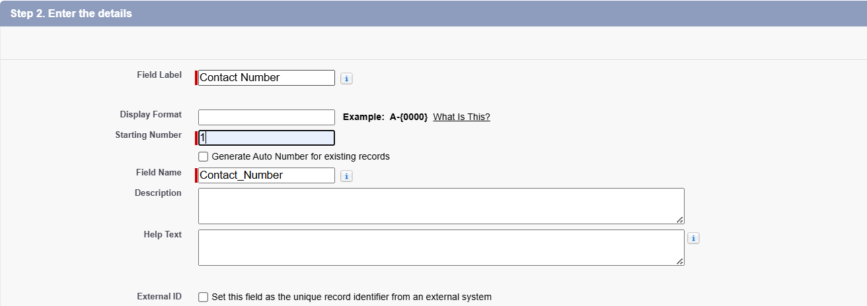

1. Click on Next >> Next >> Save and New.

# Create “Address” field in Volunteer object:

1. Go to Setup page >> Click on Object Manager.
2. Type Object name (Volunteer) in the search bar >> Click on the object.



1. Now, click on “Fields & Relationships” >> Click on New.
2. Select Datatype as “Text Area (Long)” and click on Next.



1. Fill in the Above as follows:
   * Field Label: **Address**.
   * Field Name: **Address**.
   * Click on required check box.

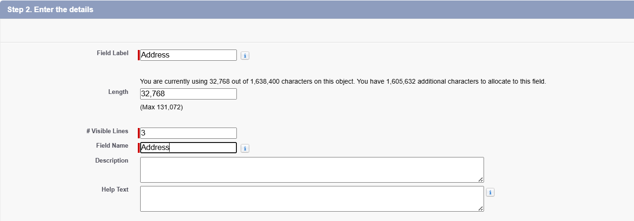

1. Click on Next >> Next >> Save and New.

# Create “Date of Birth” field in Volunteer object:

1. Go to Setup page >> Click on Object Manager.
2. Type Object name (Volunteer) in the search bar >> Click on the object.



1. Now, click on “Fields & Relationships” >> Click on New.
2. Select Datatype as “Date” and click on Next.



1. Fill in the Above as follows:
   * Field Label: **Date of Birth**.
   * Field Name: **Date_of_Birth**.

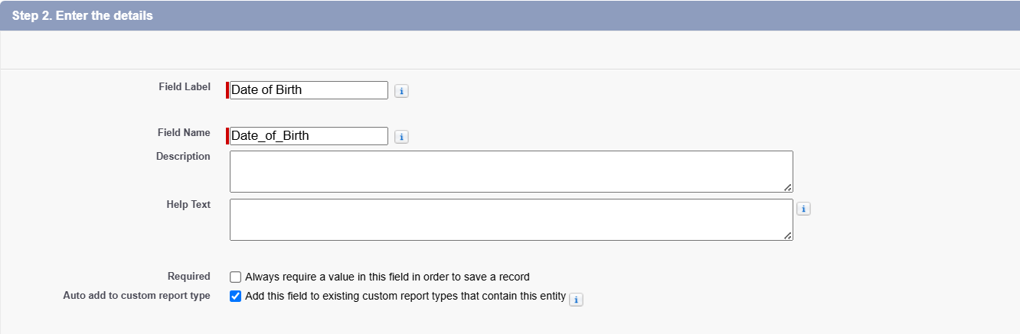

1. Click on Next >> Next >> Save.

# Activity 5: Creation of fields for the Execution Details object. Create “Execution ID” field in Execution Details object:

1. Go to Setup page >> Click on Object Manager.
2. Type Object name (Execution Details) in the search bar >> Click on the object.

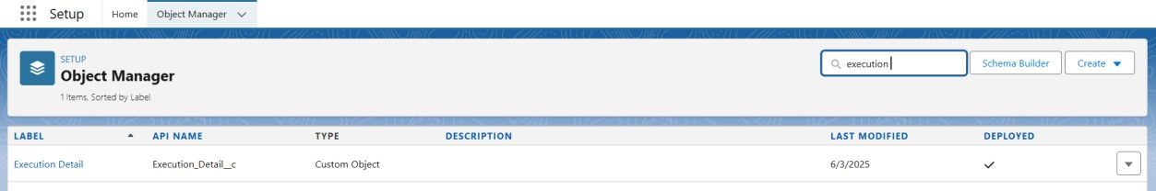

1. Now, click on “Fields & Relationships” >> Click on New.
2. Select Datatype as “Auto Number” and click on Next.

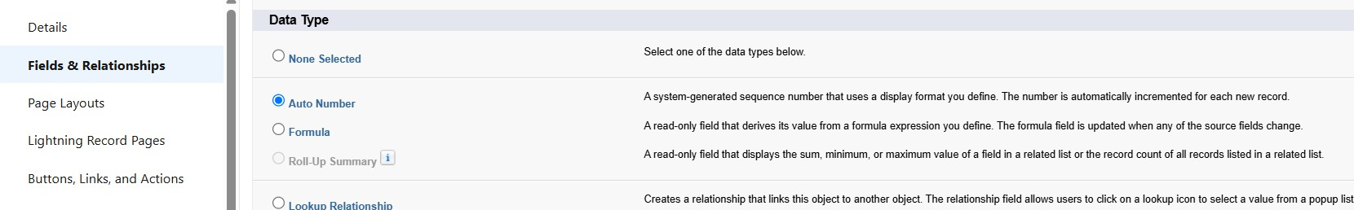

1. Fill in the Above as follows:
   * Field Label: **Execution ID**.
   * Field Name: **Execution_ID**.
   * Click on required check box.

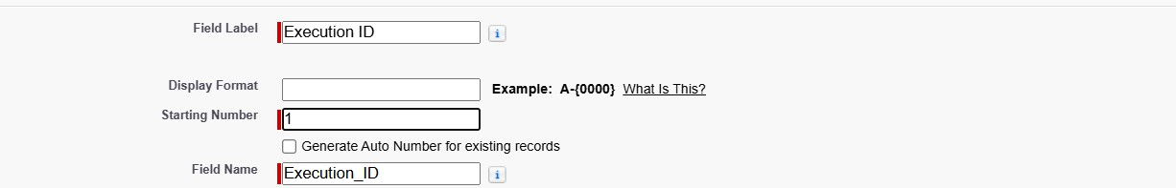

1. Click on Next >> Next >> Save.

# Milestone – 5 Flows

**Create Flow To Create A Record In Venue Object:**

1. Go to setup >> type Flows in quick find box.
2. Click on Flow and select the New Flow.

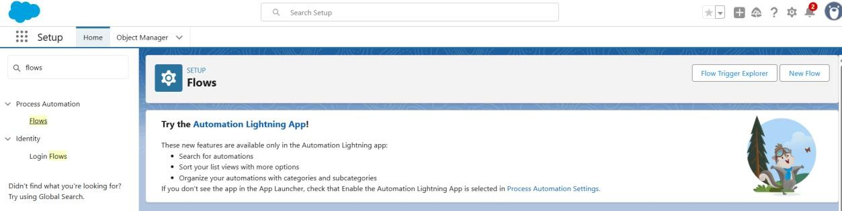

1. Click on Start from Scratch >> Click on Screen flow >> Click on Create.

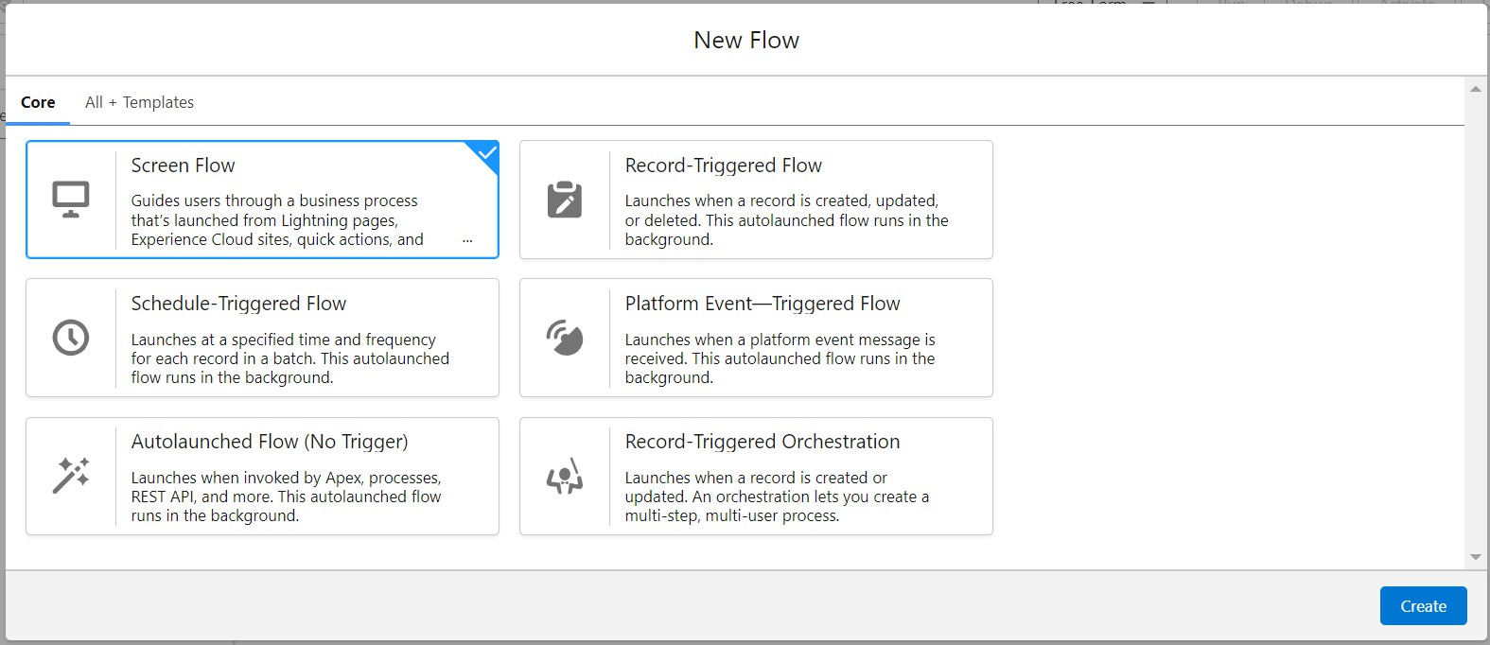

1. Click on the ‘+’ icon in between start and end, and click on screen element.
2. Under the Screen Properties: Label: Venue Details

API Name: Venue_Details

1. Now let’s add components in this flow.
2. Click on Text Component and name it as: Label: Venue Name

API Name: Venue_Name

1. Click on Email Component and name it as: Label: Email

API Name: Contact_Email

1. Click on Phone Component and name it as: Label: Phone

API Name: Contact_Phone

1. Click on Text Component and name it as: Label: Venue Location

API Name: Venue_Location

1. Click on Number Component and name it as: Label: Latitude

API Name: Latitude

1. Click on Number Component and name it as: Label: longitude

API Name: longitude

1. Next click on Done.

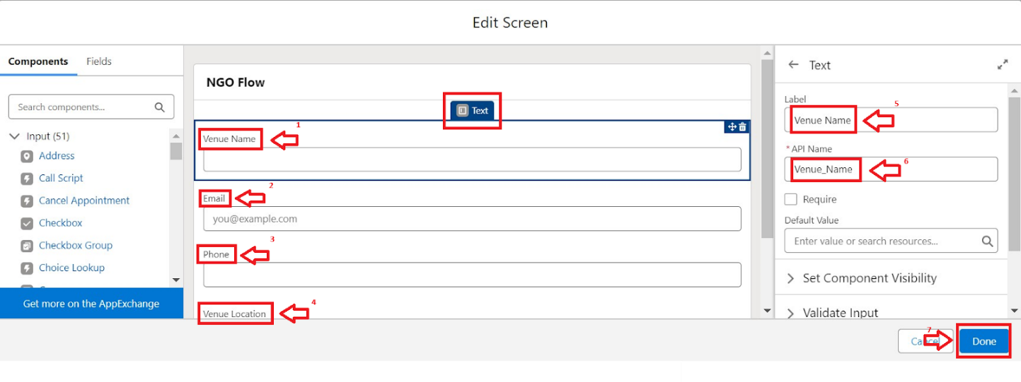

1. Click on the ‘+’ icon in between Venue details and end, and click on create record element.
2. Now label it as

Label: Create Venue Record

API Name: Create_Venue_Record.

1. How to Set the Record Field values: Select Manually(select an object and configure the record values manually)

Object: Venue

1. Set Field Values for the Venue: Click on ‘Add Field’ 5 times Field: Value = Contact_Email c : {!Contact_Email.value} Field: Value = Contact_Phone c : {!Contact_Phone.value} Field: Value = Name : {!Venue_Name}

Field: Value = Venue_Location c : {!location} Field: Value = Location Latitude s : {!latitude}

Field: Value = Location Longitude s : {!longitude}

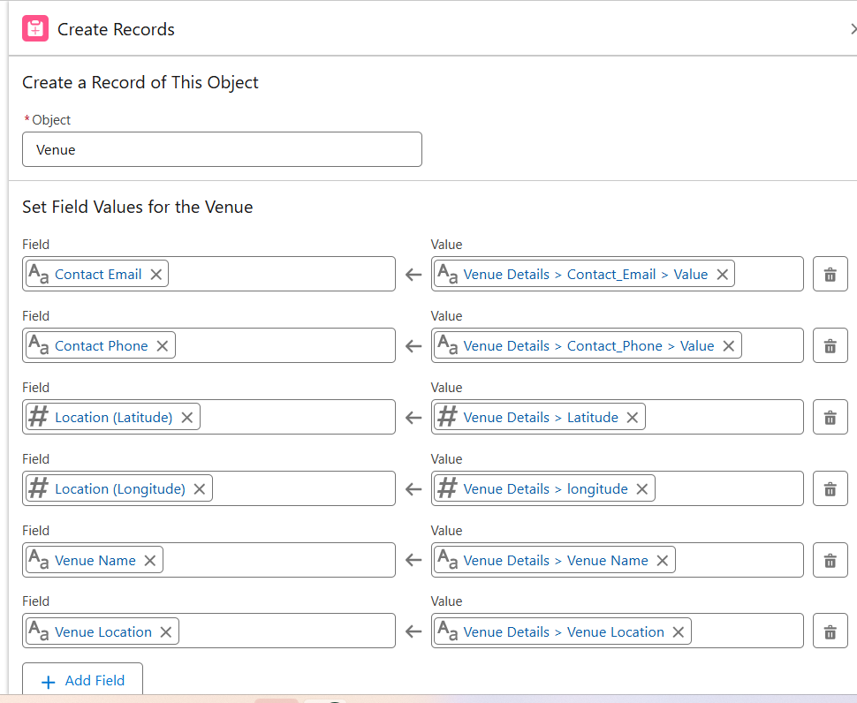

1. Click on Save as:

Flow label: **Venue Form**

Flow API Name: **Venue_Form.**

**Activity 1: Create a Trigger**

**Milestone -6**

**Trigger**

1. Log into Salesforce account >> navigate to the gear icon in the top right corner.

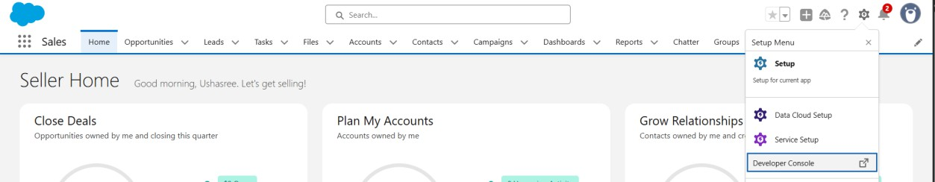

1. Click on Developer Console and you will be navigated to a new console window.
2. Click on file menu >> Click on New >> Select Apex Trigger.
3. Enter the trigger name and the object to be triggered.

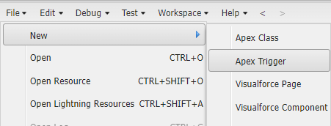

1. Enter Name: DropOffTrigger sObject: Drop-Off Point

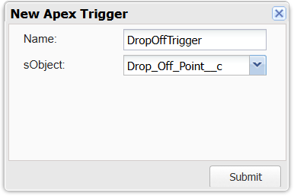

1. Click on Submit.

# Trigger Code:

Trigger to assign the Distance field to the Distance Calculation field.

# Code:

trigger DropOffTrigger on Drop_Off_point c (before insert) { for(Drop_Off_point c Drop : Trigger.new){

Drop.Distance c = Drop.distance_calculation c;

}

}

# Create NGOs Profile:

**Milestone – 7 Profiles**

1. GO to Steup page >> type profiles in quick Find bar.
2. Click on Profiles >> Click on ‘S’.

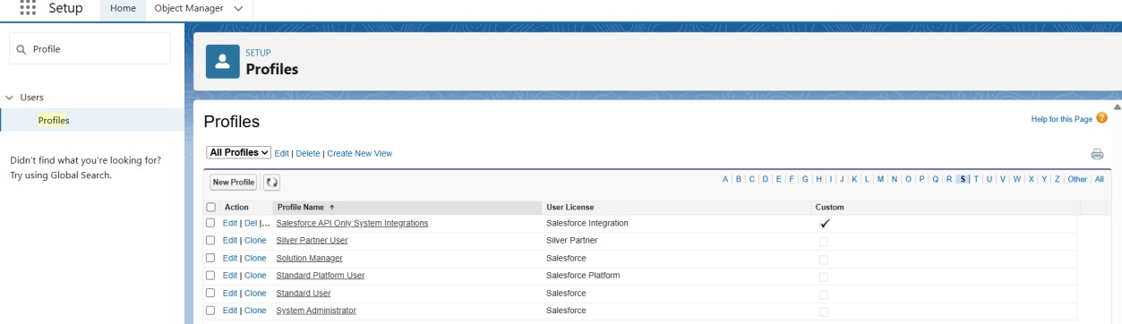

1. Click Clone beside Standard Platform User.
2. Under Clone Profile:

Profile Name: NGOs Profile

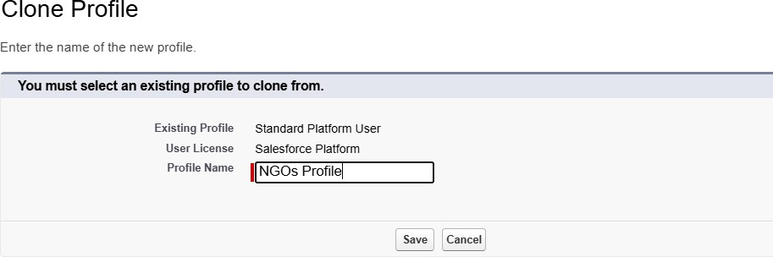

1. Click on Save.

# Milestone – 8 Creation of Users

**Activity 1: Creation of User “Iksha Foundation”**.

1. Go to Setup page >> type users in Quick find bar
2. Click on Users >> Click on New user.

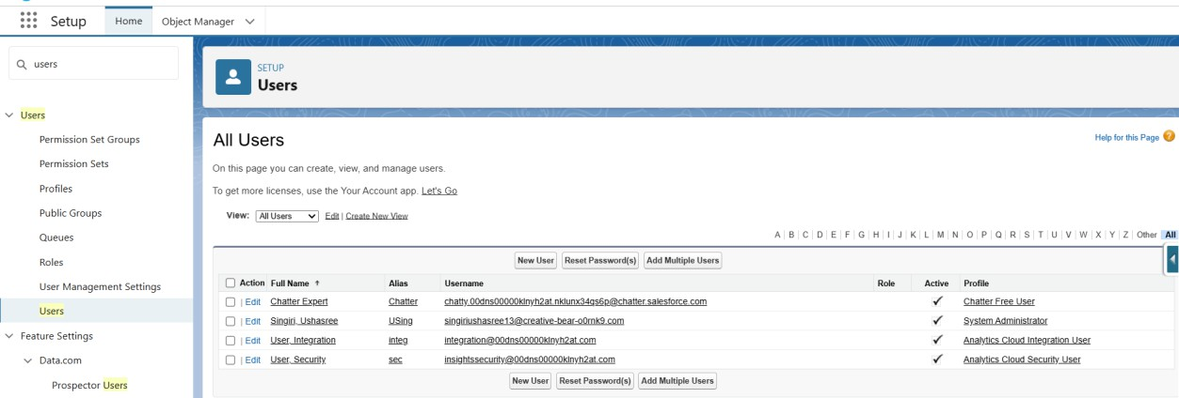

1. In General Information give details as: First Name: **Iksha Foundation** Last Name: **Iksha Foundation** Alias: iiksh

Email: [singiriushasree13@gmail.com](mailto:singiriushasree13@gmail.com) Username: [ikshafoundation1319@sb.com](mailto:ikshafoundation1319@sb.com) Nickname: Auto Populated

User License: Salesforce Platform Profile: NGOs Profile

Active: Check

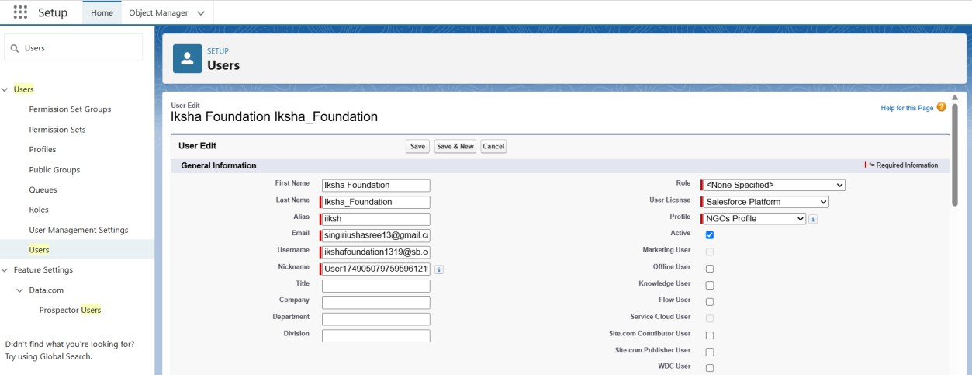

1. Click on Save.

# Activity 2: Creation of User “NSS”.

1. Go to Setup page >> type users in Quick find bar
2. Click on Users >> Click on New user.



1. In General Information give details as: First Name: **NSS**

Last Name: **NSS**

Alias: nnss

Email: [singiriushasree13@gmail.com](mailto:singiriushasree13@gmail.com) Username: [nss1319@sb.com](mailto:nss1319@sb.com) Nickname: Auto Populated

User License: Salesforce Platform Profile: NGOs Profile

Active: Check

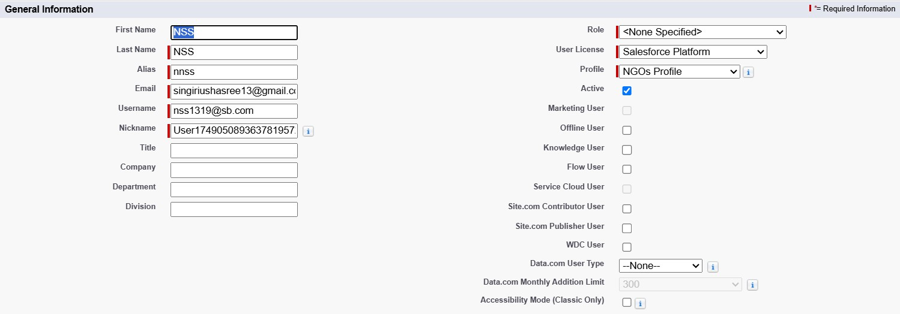

1. Click on Save.

# Creation of User “Street Cause”:

1. Go to Setup page >> type users in Quick find bar
2. Click on Users >> Click on New user.



1. In General Information give details as: First Name: **Street Cause**

Last Name: **Street_Cause**

Alias: sstre

Email: [singiriushasree13@gmail.com](mailto:singiriushasree13@gmail.com) Username: [streetcause1319@sb.com](mailto:streetcause1319@sb.com) Nickname: Auto Populated

User License: Salesforce Platform Profile: NGOs Profile

Active: Check

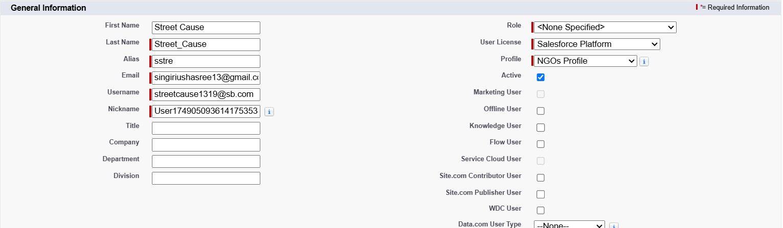

1. Click on Save.



# Milestone – 9 Public Groups

**Activity 1: Create a Public Group “Iksha”.**

1. Go to the setup page >> type Public Groups in Quick Find bar
2. Click on Public Groups >> Click on New.

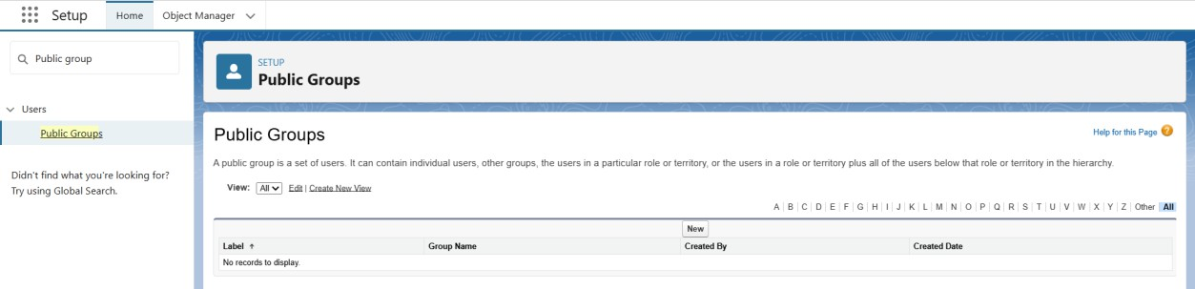

1. Under Group Information: Label: Iksha

Group Name: Iksha

Grant Access Using Hierarchies: Check

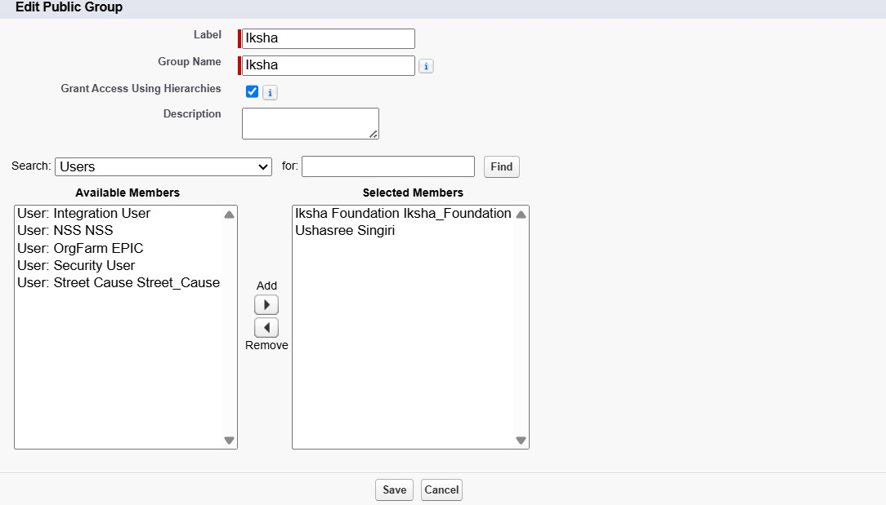

1. In Search, Select Users.
2. In Selected Members, Add Iksha Foundation and System Administrator

# Activity 2: Create a Public Group “NSS”.

1. Go to the setup page >> type Public Groups in Quick Find bar
2. Click on Public Groups >> Click on New.



1. Under Group Information: Label: NSS

Group Name: NSS

Grant Access Using Hierarchies: Check

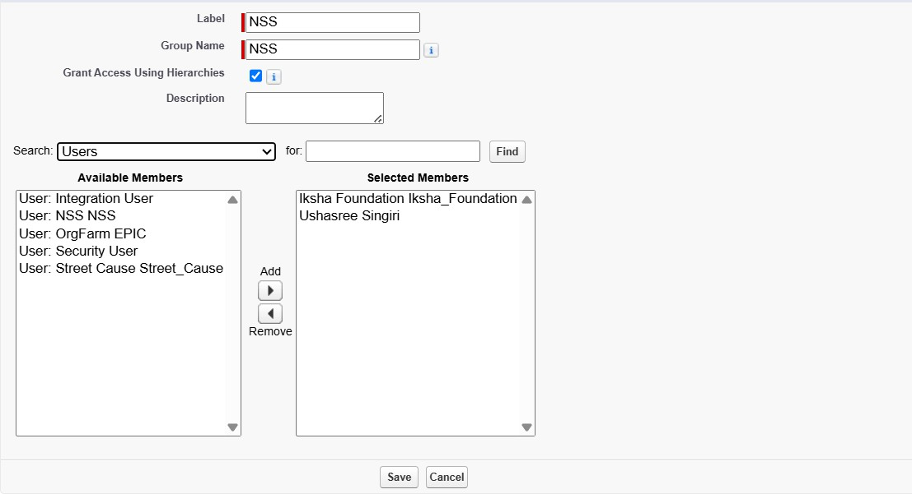

1. In Search, Select Users.
2. In Selected Members, Add Iksha Foundation and System Administrator

# Create a Public Group “Street Cause”:

1. Go to the setup page >> type Public Groups in Quick Find bar
2. Click on Public Groups >> Click on New.



1. Under Group Information: Label: Street Cause

Group Name: Street_Cause

Grant Access Using Hierarchies: Check

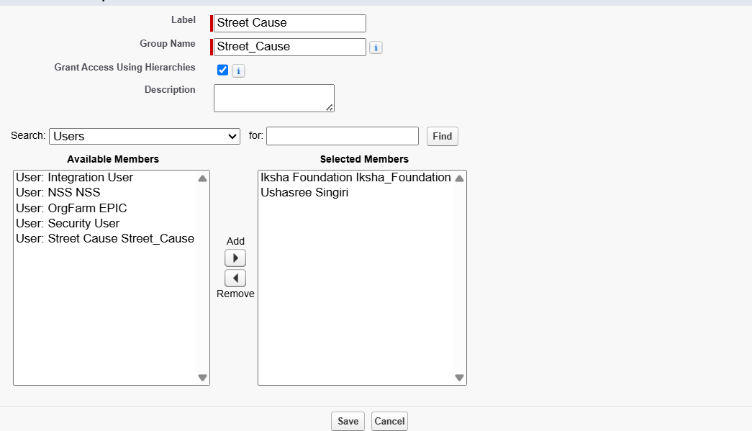

1. In Search, Select Users.
2. In Selected Members, Add Iksha Foundation and System Administrator



# Creation Of Report Types:

**Milestone -10 Report Types**

1. Go to Setup page >> type Report Types in quick find bar.
2. Click on Report Types >> Click on Continue >> Click on Custom Report Type.

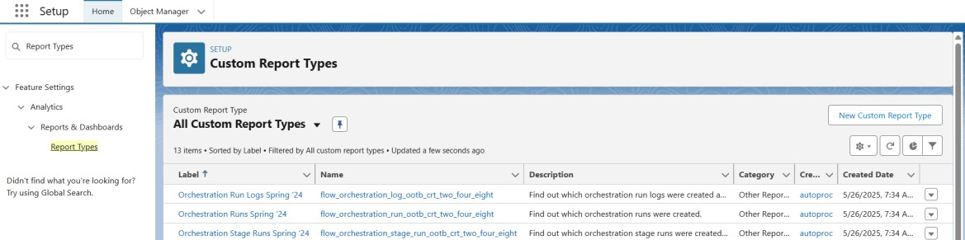

1. In Define the Custom Report Type: Primary Object: Select Venues

Report Type Label: **Venue with DropOff with Volunteer** Report Type Name: **Venue_with_DropOff_with_Volunteer** Description: Venue with Drop-Off with Volunteer

Store in Category: Select other Reports Deployment status: Deployed

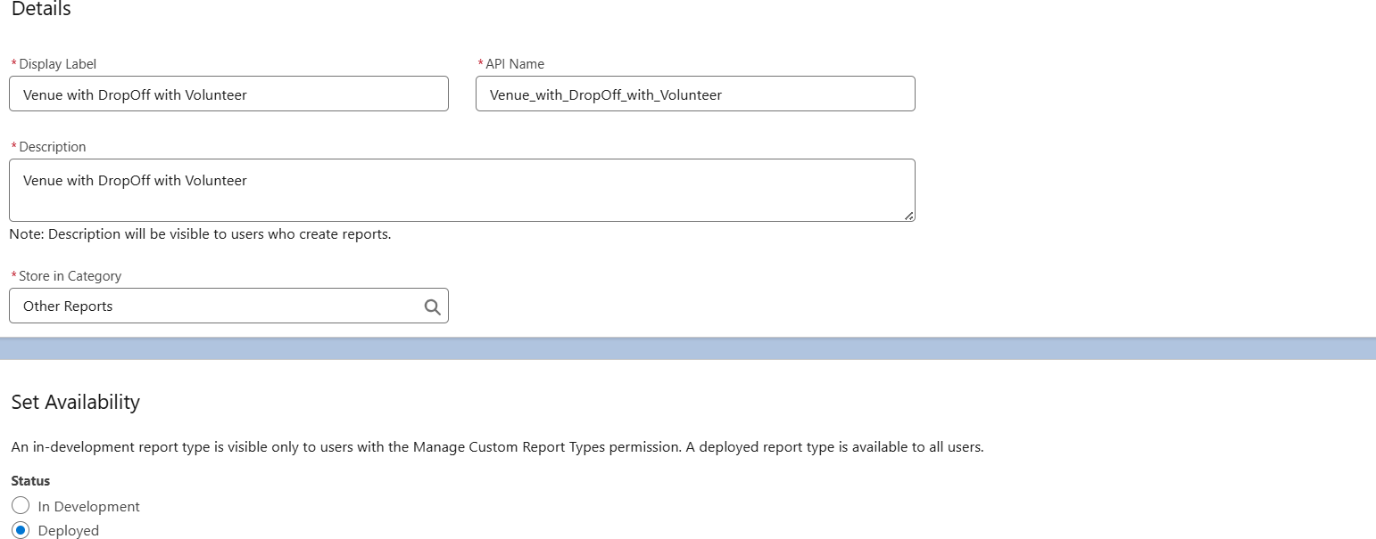

1. Click on Next
2. Near click to relate another object. Select Drop-Off Points.
3. Select “A” records may or may not have related “B” records.
4. Again, Near Click to relate another select volunteer.

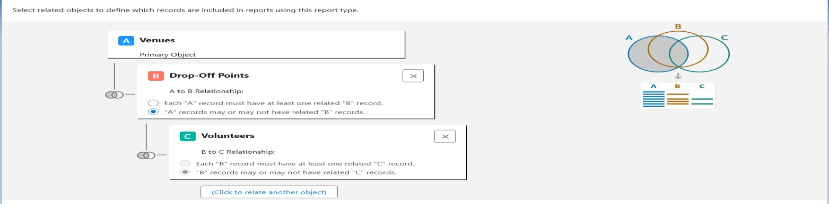

1. Click on Save.

# Milestone – 11 Reports

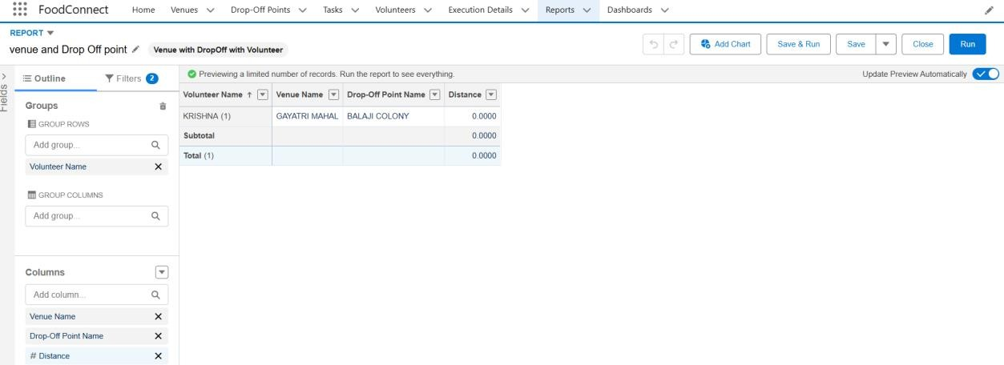

**Activity 1: Creation of Report On Venue With DropOff With Volunteer:**

1. Go to the app (FoodConnect) >> Click on the reports tab.
2. Click on New Folder.

Folder Label: Custom Reports

Folder Unique Name: CustomReports

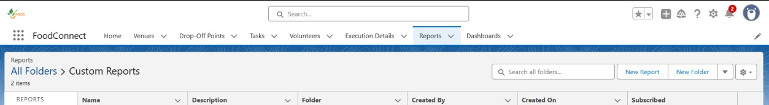

1. Open Custom Reports and click on New Report
2. Select Report Type: Venue with DropOff with Volunteer Then Click on Start Report.
3. In GROUP ROWS: Add Volunteer Name
4. In COLUMNS: Add Venue Name, Drop-Off Point Name, Distance.
5. Click on Save and Run
6. Give Label as:

Report Name: venue and Drop Off point Report Unique Name: Auto Populated

1. Click on Select Folder and Select Custom Report >> Click on Save.

# Activity 2: Creation of Report on Volunteer with Execution Details and Tasks:

1. Go to the app (FoodConnect) >> Click on the reports tab.
2. Open Custom Reports and click on New Report.



1. Select Report Type: Volunteers with Execution Details and Tasks. Then Click on Start Report.
2. In GROUP ROWS: Add Volunteer ID
3. In COLUMNS: Add Volunteer: Volunteer Name, Task: Task Name, Execution Detail: Execution Detail Name, Volunteer: Owner Name, Task: Date, Task: Rating.
4. Click on Save and Run.
5. Give Label as:

Report Name: Volunteer Task

Report Unique Name: Auto Populated

1. Click on Select Folder and Select Custom Report >> Click on Save.

# Vjmo”}?Milestone – 12 Dashboards

**Activity 1: Adding Venue and Drop Off Point Report to the Dashboard:**

1. Go to the app (FoodConnect) >> Click on the reports tab.
2. Click on New Folder.

Folder Label: Custom Dashboards Folder Unique Name: Dashboards

1. Open Custom Dashboards and click on New Dashboards. Name: Organization Details

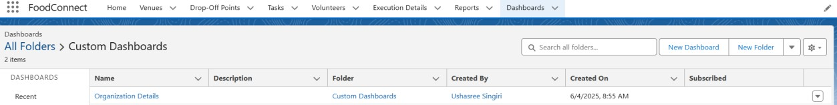

1. Click on Widget and select Chart or Table
2. In Select Report: Select venue and Drop Off Point Report >. Click on select
3. In Add Component:

Display as: Select Lightning Table Component Theme: Select Dark

1. Now Click on Add.

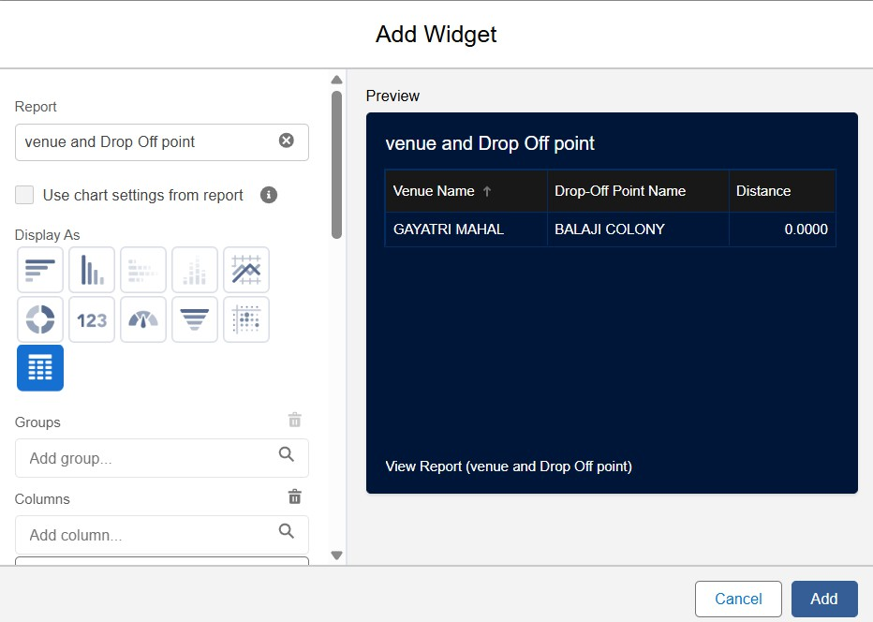

# Activity 2: Adding Venue And Drop Off Point Report to the Dashboard.

1. Go to the app (FoodConnect) >> Click on the reports tab.
2. Open Custom Dashboards and click on Organization Details.
3. Click on Widget and select Chart or Table
4. In Select Report: Select Volunteer Task Report >. Click on select
5. In Add Component:

Display as: Select Line Chart Component Theme: Select Dark

1. Now Click on Add.

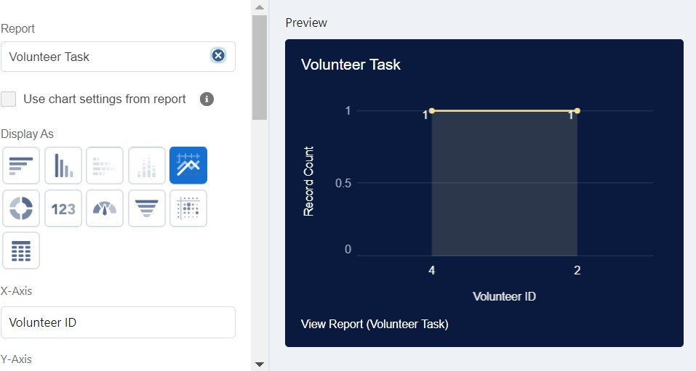

# Activity 3: Adding a Picture to the Dashboard

1. Click on Widget >> Select Image >> Click on Browse Files.
2. Select the Picture you want to upload.
3. Then Click on Save As: Name: Task Execution Details
4. Click on Select folder and Custom Dashboards.

# Milestone – 13 Sharing Rules

1. Go to Setup >> type Sharing Settings in quick find box.
2. Click on the Sharing Settings.
3. Click on New near Drop-Off point Sharing Rules and Name it as: Label: Rule 1

Rule Name: Rule_1

1. Select your rule type: Select Based on Criteria.
2. Select which reports to be shared:

Field: Operator: Value = Distance: less than: 15

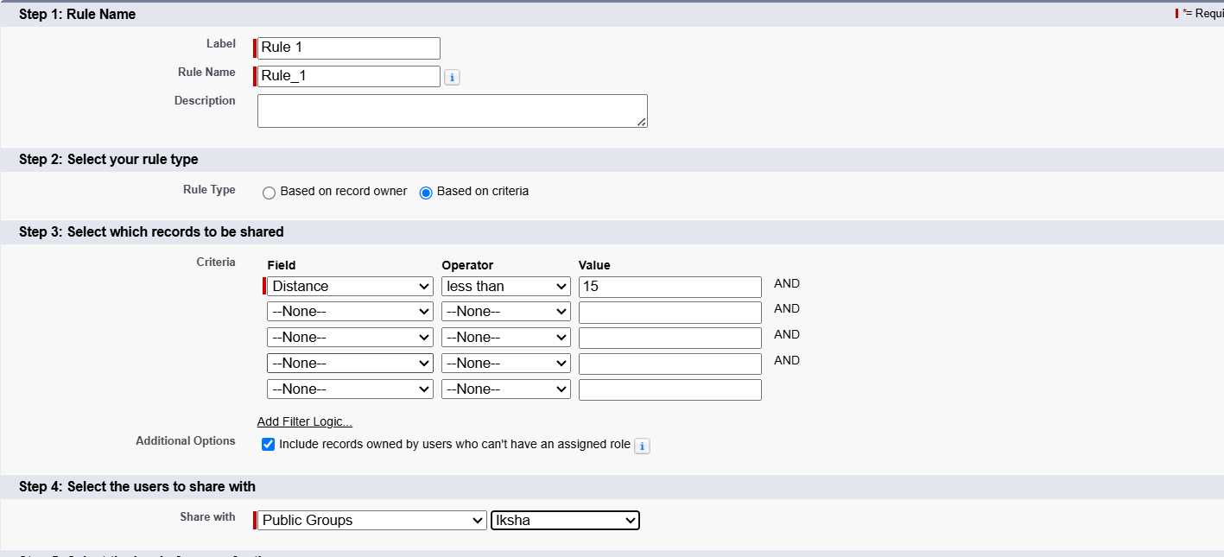

1. Select Users to share with: Near Share with: Public Groups: Iksha
2. Click on Save.
3. Click on new near Drop-Off Point sharing rules and name it as: Label: Rule 2

Rule Name: Rule_2

1. Select your rule type: Select Based on Criteria.
2. Select which records to be shared:

Field: Operator: Value = Distance: greater than: 15 Field: Operator: Value = Distance: Less or equal: 30

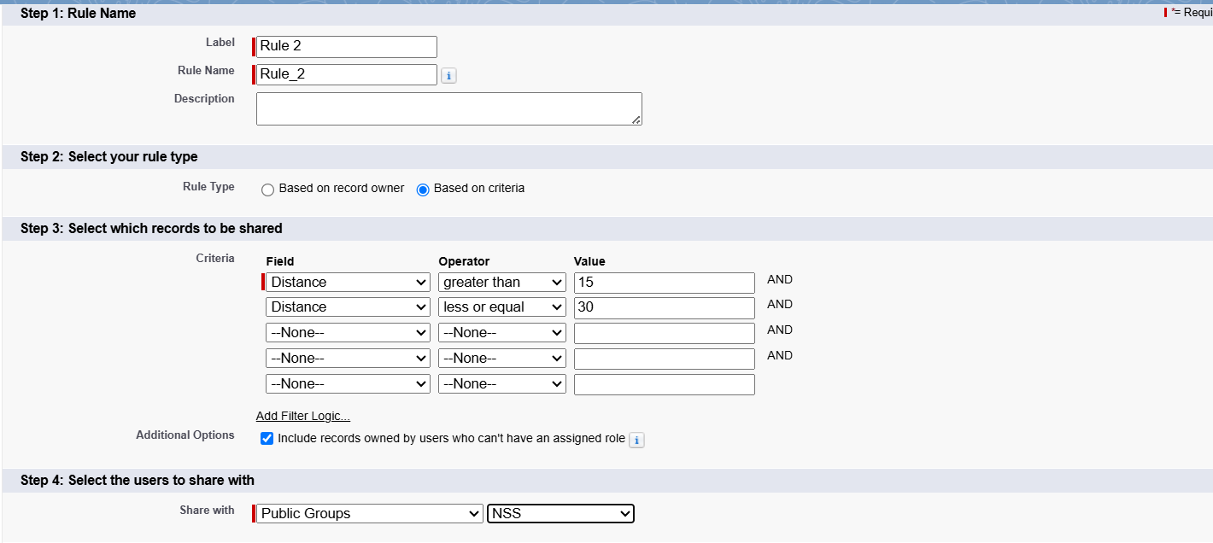

1. Select the users to share with: Near Share with Public Groups: NSS
2. Click on Save.
3. Click on new near Drop-Off Point sharing rules and name it as: Label: Rule 3

Rule Name: Rule_3

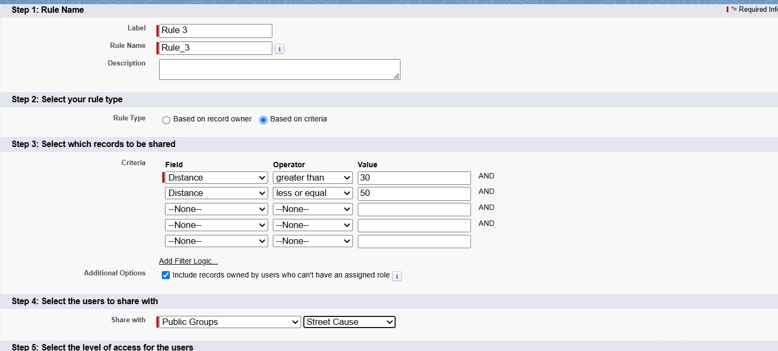

1. Select your rule type: Select Based on Criteria.
2. Select which records to be shared:

Field: Operator: Value = Distance: greater than: 30 Field: Operator: Value = Distance: less or equal: 50

1. Select the users to share with: Near Share with Public Groups: Street Cause
2. Click on Save.

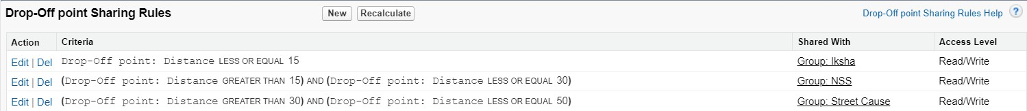

# Milestone – 14 Home Page

**Activity 1: Creation of Home Page.**

* 1. Go to Setup >> type Lightning App Builder in the quick find box.
  2. Click on Lightning App Builder >> Click on New.
  3. Select Standard Home Page.
  4. Near Components search for Flow and Drag and Drop in the Right Side Section
  5. On the right hand side:

Flow: Venue Flow

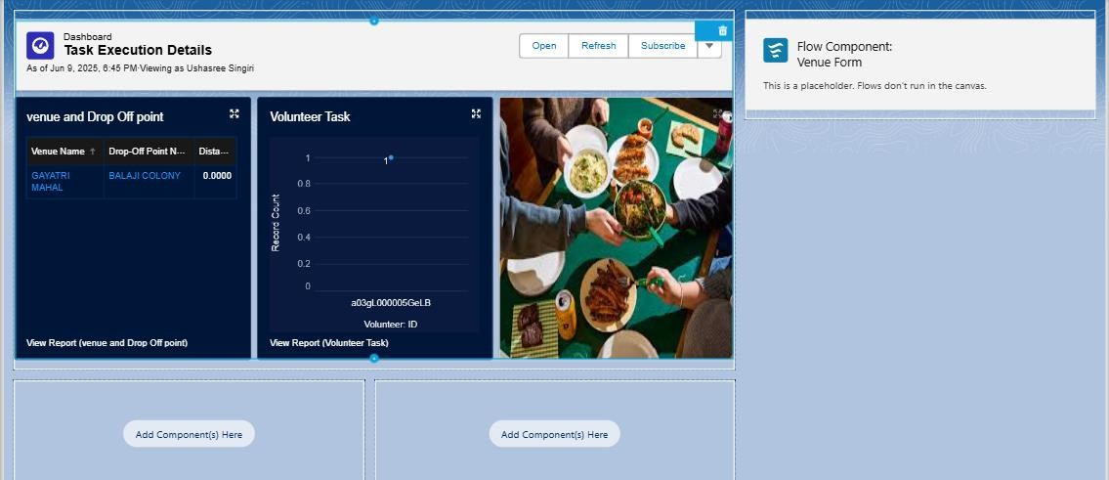

* 1. Near Components search for Dashboard, the Drag and Drop it in First Section.
  2. Click on Save and Activation. Then click on the App Default. Then add Assignments.
  3. Add FoodConnect App and then Save.
  4. FoodConnect Home Page would look like this.

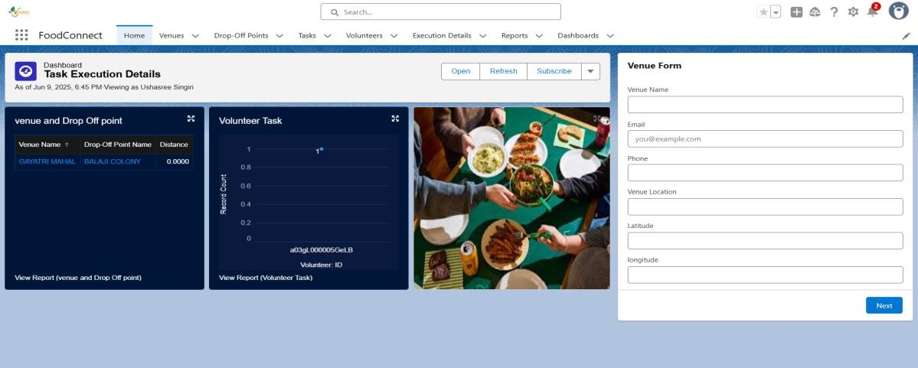

**Home page**

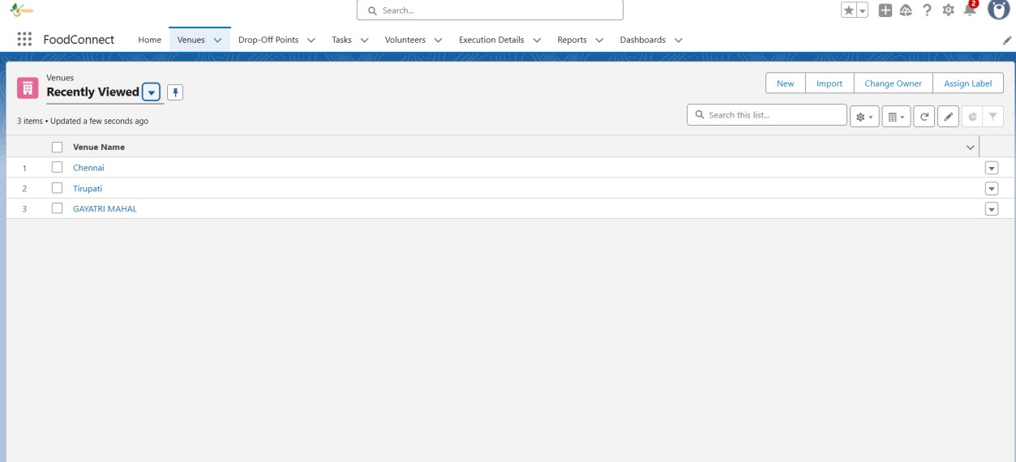

**Venue page**

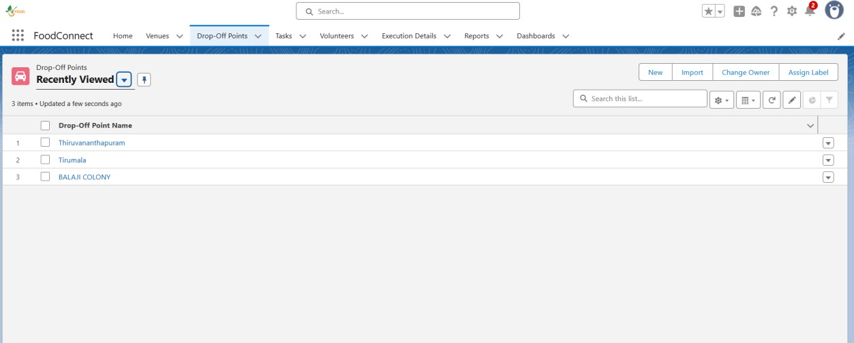

**Drop-Off Point**

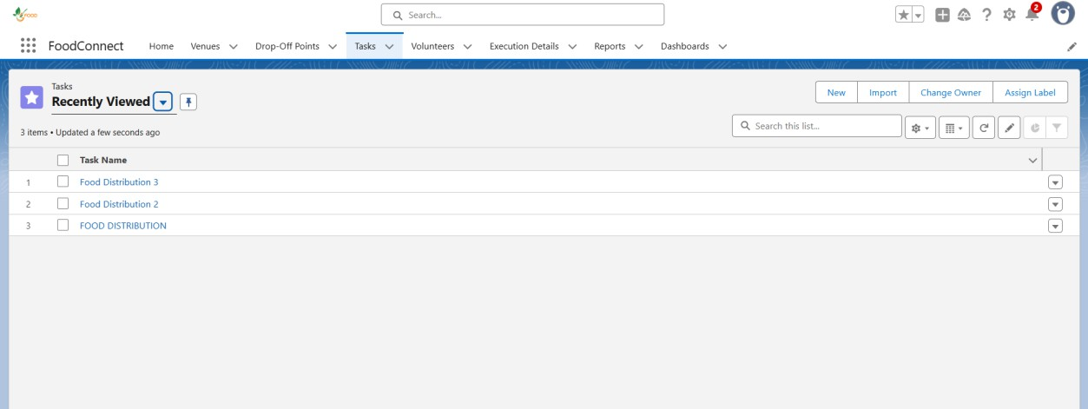

**Tasks page**

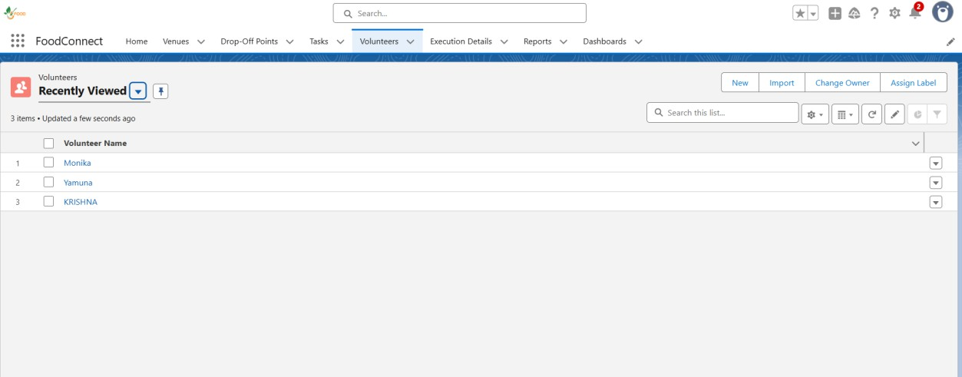

**Volunteers page**

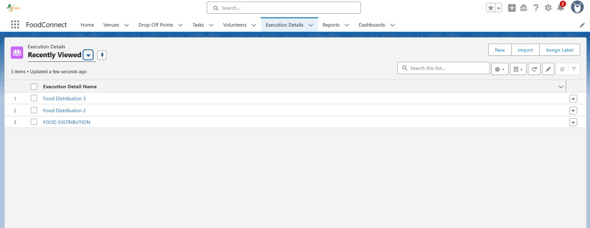

**Execution Details page**

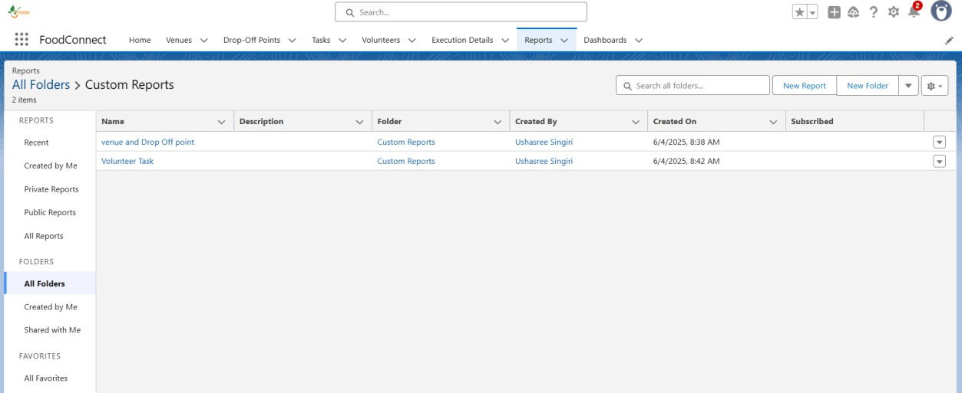

**Reports page**

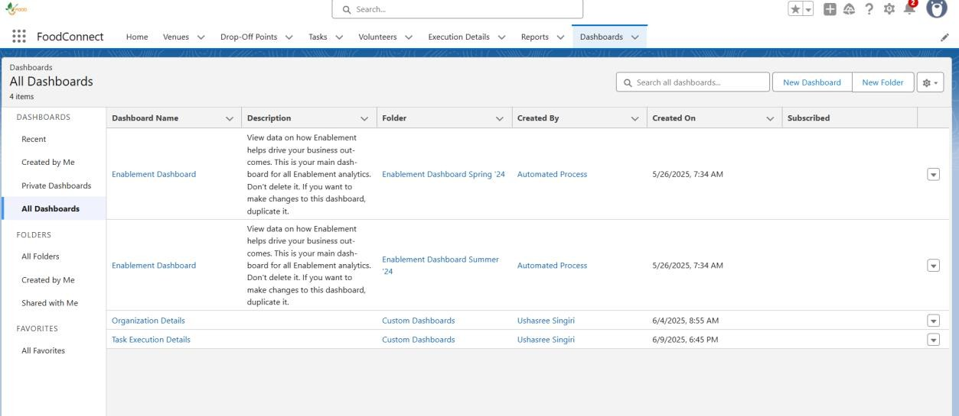

**Dashboards page**

**Milestone – 15 Conclusion**

By leveraging the Salesforce platform, the project successfully established a streamlined and transparent system for managing surplus food donations. Through efficient coordination with volunteers and timely delivery to beneficiaries, the project effectively addressed food insecurity while maximizing the utilization of available resources.